Worldmaking as we know it always starts from worlds already on hand; the making is a remaking.
Dr. Samantha Henriette Krukowski
University of Texas at Austin
CMB 6.118
Austin, TX 78 78712-1091
samantha@rasa.net

Collaborators: Jeremy Beaudry, Doug Denny,
Tray Duncan, Ken Dykes, Eleanor Eichenbaum,
Niten Kapadia, Kristin Peterson,
Kaz Raad, John Slatin

Negotiating the Space between Real and Virtual Worlds (Online ID 0244)

⎯Nelson Goodman, Ways of Worldmaking

Introduction
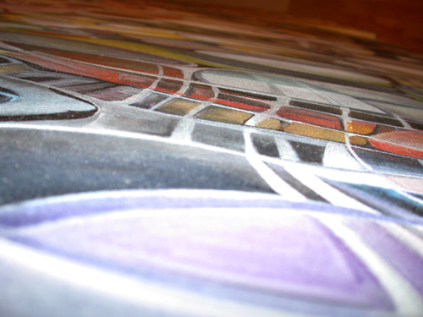
A painting is a landscape of possibilities⎯a form field, a material experiment, a background or foreground, a place of play and imagination. Photographs of people looking at paintings reveal them looking into them, finding things in them that were never consciously put down, never put on the canvas. The way people look at paintings requires a painter to remember the world outside of the work that it, itself, points to. Not only is the materiality of the painted field interesting⎯its image, vibrant hues and liquid surfaces. What is increasingly interesting, given the possibilities of expanded visualization systems, is how a painting might move into and out of itself, towards and away from its material existence, based on what may or may not be found in its home medium. This project relocates a painting as the site of an immersive environment where the painting's fundamental components generate the parameters of a multi-modal, multi-sensory experience. If a painting is the primary plane from which to derive an immersive environment, then a painting becomes an event-scape whose order and components only begin in the painting of derivation.

The Process
At the heart of an exercise like this is the understanding that the relationship between digital imagery and material imagery is grounded in equal exchange—lest we lose ourselves completely in the belief that digital images are the only images of the future, there is value in the wonder and exploration of how the digital and non-digital act in the in-between.
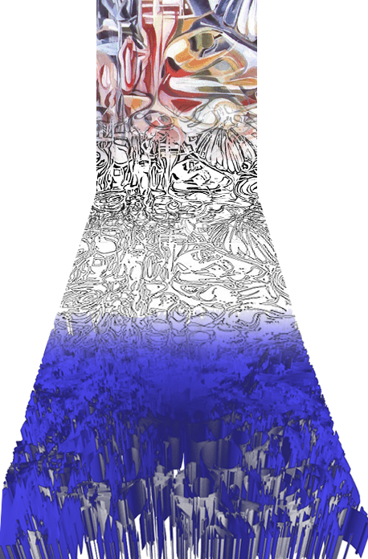
Start with a large painting on canvas. Digitize that image and submit it to a number of transformations: isolate color values, convert it to a pure vector image, extrude these vectors to create a three-dimensional form. Or locate various hot-spots in the painting which suggest worlds within themselves. Make bas relief models of these. Interpret them through touch and describe them in words. Locate more hot-spots. Translate the forms into an alphabet, a vocabulary of symbolic objects which suggest “notes”. Graph these notes onto the fret of a guitar and generate chords, generate intuitive sound phrases. Or import these “notes” into a computer program which then generates a score from these images. Take these components into the VISLAB and assemble, project, tweak, broadcast them. Discover “narratives” which suggest procedures, frameworks, possibilities for interaction. Videotape and photograph this environment, make drawings of it. Start over from the beginning…

Immersion, the VISLAB, and Accessibility
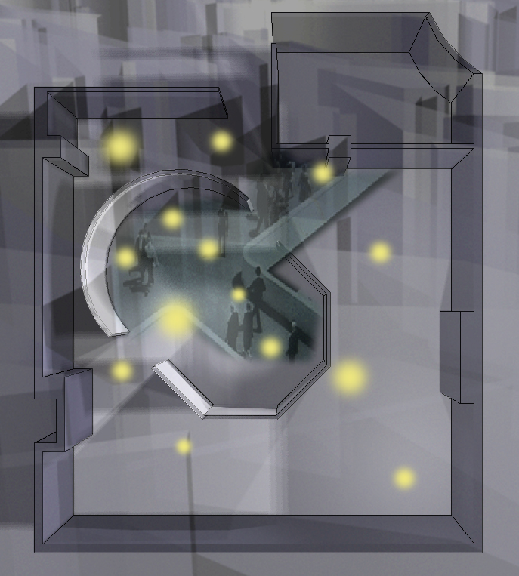
Equally significant for this investigation is the awareness of certain conventions and histories which describe the recent trajectories of visualization systems and immersive environments. However powerful the hardware and software inside the contemporary visualization laboratory may be, this technology is still tempered by inherent limitations imposed by the current restrictions of the given technology and by the reluctance of investigators to visualize anything other than that which can be mathematically preconceived. The VISLAB often becomes a theatre of passive observance, hindered by its desire to remain within the confines of the digital machine and the projection screen. This project attempts to actively rediscover and reaffirm the potential interactivity of the VISLAB by creating a meaningful space of participation where numerous nodal points of interaction present themselves to the participant⎯whether in the form of images, touch, text, audio, ritual performance and creative engagement.

We are very conscious of the limitations of a space like the VISLAB and have taken to task the issue of accessibility, both as it relates to potential participants who are hearing or seeing impaired, but also as it relates to the exclusivity of such high-end, privatized, somewhat intimidating facilities. Some important questions here are:

How can various components of the immersive environment within the VISLAB come together to provide rich experiences for persons who are seeing or hearing impaired? In other words, how can the experience of the visualization lab allow for more than merely seeing? What are the established parameters for an immersive experience and how do these “rules” allow the participant to freely explore this overwhelming technology? As the experience is pushed beyond the boundaries of the computer and projection, how might the immersive environment be exported beyond the physical walls of the VISLAB in order to reach a greater number of participants who may not have access to the actual facility?

For more information, please visit: http://www.aces.utexas.edu/sam/aces.html

