Project Proposal for
A-Bumper Impact
Test Design

Submitted to:

Rafael de la Paz, Project Coordinator
HDC, Inc.
Austin, Texas

Prepared by:

Chris Delzell
Jeff Dieterich
Chris Kuryak, Team Leader
Albert Martinez

Mechanical Engineering Design Projects Program
The University of Texas at Austin
Austin, Texas

Summer 2006

Table of Contents
Table of Contents i
List of Figures iv
List of Tables v
1. INTRODUCTION 1
2. COMPANY BACKGROUND 1
2.1 HDC, Inc. 1
2.2 A-Bumper Purpose 2
2.3 A-Bumper Function 4
3. PROBLEM STATEMENT 5
4. REQUIREMENTS AND CONSTRAINTS 5
4.1 Requirements 5
4.1.1 Maximum Forces 7
4.1.2 Repeatability 7
4.1.3 Instrumentation 8
4.2 Constraints 8
4.2.1 Safety 9
4.2.2 Transportability 9
5. DELIVERABLES 9
5.1 Phase I Deliverables 9
5.2 Phase II Deliverables 10
6. COMPLETED WORK 11
6.1 Overview 11
6.2 Research 12
6.3 Concept Generation 13
6.4 Concept Selection 13
6.5 Testing Parameters 14
6.6 Impact Testing Location 15
6.7 Barrier Calculations 17
6.8 Measurement Devices 19
6.8.1 Velocity 19
6.8.2 Bumper Deformation 20
6.8.3 Impact Duration 22
6.8.4 Vehicle Acceleration 23
6.8.5 Vehicle Mass 24
6.9 Data Acquisition Setup 24
6.9.1 DAQ Board and LabVIEW 25
6.9.2 Wiring 26
6.9.3 Instrument Calibration 26
6.10 Impact Testing 32
6.11 Data Collection 33
7. FUTURE WORK 36
7.1 Cost Analysis 36
7.2 Data Analysis 36
7.2.1 Parameter Summary 36
7.2.2 Energy Dissipated 37
7.2.3 Peak Acceleration 37
7.2.4 Impact Force 38
7.2.5 Video Synchronization 38
7.3 Material Research 39
7.4 Analytical and Predictive Modeling 39
7.5 Data Interpretation 40
8. CONCLUSION 41
8.1 Final Remarks 41
REFERENCES 42
APPENDIX A: Mind Maps 1
APPENDIX B: Concept Selection 1
APPENDIX C: PMDC Motor Specifications 1
APPENDIX D: DAQ Board 1
APPENDIX E: LabVIEW Program 1
APPENDIX F: Gantt Chart 1

List of Figures
Figure 1. A-Bumper Pads [1] 2
Figure 2. Mounted A-Bumper [1] 3
Figure 3. A-Bumper Mounting [1] 4
Figure 4. Concrete K-Rail Layout 18
Figure 5. Deformation Measuring Device 21
Figure 6. Impact Duration Circuit 22
Figure 7. Instrumentation and DAQ Connectivity 27
Figure 8. PMDC Motor Calibration Setup 28
Figure 9. PMDC Motor Calibration Graph 29
Figure 10. Accelerometer Calibration Graph 31
Figure 11. Contact Switch Calibration Setup 32
Figure 12. Un-deformed A-Bumper 34
Figure 13. Deformed A-Bumper 34
Figure 14. Video Camera Placement 35

List of Tables
Table 1. Specification Sheet 6

1. INTRODUCTION
A senior design project is a graduating requirement of all students in the Mechanical Engineering Department at the University of Texas at Austin. Each project is created and sponsored by companies who would benefit from the research of mechanical engineering students. Harvey Distributing Company (HDC), Inc. has provided a project that involves testing and validating the effectiveness of a rubber bumper for utility vehicles. The team members assigned to this project include Chris Delzell, Jeff Dieterich, Chris Kuryak, and Albert Martinez. This project was chosen because it is an open-ended problem that offers multiple design avenues to demonstrate several engineering methodology techniques. Compared to the projects offered by other companies, this one also appeared practical, interesting, and exciting.

2. COMPANY BACKGROUND

2.1 HDC, Inc.
HDC, Inc. is the sponsor of the A-Bumper project and recently moved to Austin, Texas from Grass Valley, California. They specialize in property protection for both personal and commercial vehicles. Fourteen years ago marked the birth of the company and the introduction of their product, a power locking device. It was a customizable protection system that utilized a linear actuator and deadbolt to secure valuables inside of a compartment. The actuator was connected to the deadbolt such that the lock could be engaged and disengaged with ease.
The power locking device found large acceptance in the commercial vehicle market. Ambulances, fire trucks, service vehicles, and rescue vehicles all have a large number of individual external compartments that contain valuable items. The design flexibility of HDC’s product proved useful for securing these compartments and became an OEM (Original Equipment Manufacturer) level installment in these vehicles. This product is now well-known throughout the power locking community under the trademark name P.O.P.Locks TM, which stands for “Protect One’s Property.” [1]

A-Bumper Purpose
Since the inception of the company, HDC, Inc. has vastly expanded their product range. They now offer everything from motion detectors to trunk bed protection systems. Their newest product is the A-Bumper, which is the focus of the project this semester. The A-Bumper is a set of rubber pads that replace the stock bumper of utility vehicles. See Figure 1 and Figure 2.
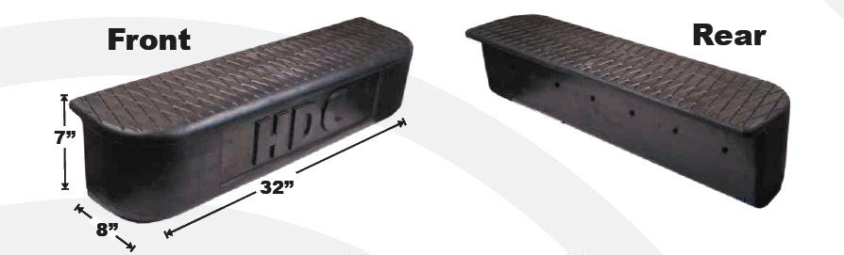

Figure 1. A-Bumper Pads [1]

Figure 2. Mounted A-Bumper [1]

The main purpose of this product is to reduce the damage inflicted on an automobile in a low speed impact. Utility vehicles are exposed to collision prone environments more often than normal cars. Whether it is a construction site, busy street, or rural dirt road, low speed impacts are a very common occurrence. The rear bumper of the vehicle usually receives damage because it is in a position that is out of the driver’s view. Backing into poles, trees, and walls are typical collisions that occur in these environments. Utility vehicles also usually have all-metal bumpers. Under low impact collisions, these bumpers permanently deform and some of the load may be transferred to the rest of the body, resulting in costly damage. [1]

2.3 A-Bumper Function
The purpose of the A-Bumper is to eliminate or reduce any damage to the vehicle in a low speed impact. First, the rubber material does not permanently deform as easily as a typical metal bumper. This provides for enhanced energy absorption and reduced damage to the bumper itself. Under a low speed collision, the A-Bumper should elastically deform to absorb the impact energy, then release back to its original position so that no damage is received by the bumper or vehicle body. Each A-Bumper contains one row of crush cells along its length. During the collision, the crush cells enhance the elastic behavior of the bumper pads by allowing space for deformation. See Figure 3.

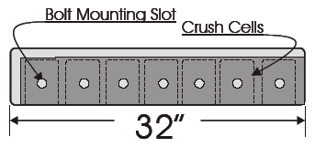

Figure 3. A-Bumper Mounting [1]

As the impact force increases, they will compress in on themselves much like springs, then expand as the force decreases. The crush cell technology combined with the elastic rubber material should provide enough energy absorption to protect the vehicle from any costly damage. In the event that the impact is strong enough to cause permanent deformation and damage to the A-Bumper, each of the pads can be replaced individually. The A-Bumper pads mount to the bumper frame with seven standard size bolts and washers. Thus, the replacement of these bumper pads is quick and easy. The enhanced energy absorption and low cost should make the A-Bumper an efficient alternative to standard utility vehicle bumpers.

3. PROBLEM STATEMENT

The main goal of the project is to justify the cost saving benefits of the rubber A-Bumper in comparison to stock utility bumpers. Specifically, the project will entail designing and conducting a test for low speed, rear bumper barrier impacts. The data collected in these trials will be analyzed and used to compare the performance characteristics between the A-Bumper and a stock utility bumper.

4. REQUIREMENTS AND CONSTRAINTS

4.1 Requirements
Several requirements have been defined to guarantee successful impact testing and data analysis. These requirements specify criteria for data acquisition and cost efficient destructive testing of the A-Bumper. All requirements and constraints listed in the following subsections are derived from the specification sheet, Table 1.

Table 1. Specification Sheet
Table 1. Specification Sheet

4.1.1 Maximum Forces
The crash barriers will be required to repeatedly withstand the forces created by the collision of the test vehicle. The force the barrier must withstand is determined using equation 1:
$$F=\frac{{\text{mV}}^{2}}{2d}$$
(eq. 1)

This equation calculates the force produced when a 6,500 pound (m) vehicle stops within a distance of 3 inches (d) while traveling at a velocity of 5 miles per hour (v). According to manufacturer specifications, the curb weight of a Ford F-150 with a utility bed is approximately 6500 pounds. The speed was defined as a standard low speed impact test value from Insurance Institute Highway Safety. The stopping distance was determined by an assumed amount of bumper deformation of 3 inches which is half of the bumper depth, a reasonable maximum bumper deformation. These values result in a maximum force of 97 kN.

4.1.2 Repeatability
The tests will be designed for repeatability. Since more than one collision will be conducted, no damage must be inflicted on the vehicle. If the impact tests caused significant damage to the vehicle, then vehicle would have to be replaced after each test. This would prove to be very expensive and inefficient. To accommodate for this requirement, the impact speed will be incrementally increased until any noticeable damage to the vehicle occurs. Then the testing will be stopped and higher impact speeds will not be tested.

4.1.3 Instrumentation
To quantify the severity of the impacts, velocity and acceleration measurements will be made during each test. The acceleration measurement device will have a sampling rate of 1,000 Hz and a sensitivity of 0.1 m/s². The velocity measurement device will be capable of a 1,000 Hz sampling rate and sensitivity to 0.01 m/s. These specifications are necessary for accurate data measurement. Sample SAE low speed impact data revealed that an average contact duration was 0.3 seconds, change in acceleration was 9.0 m/s², and change in velocity was 0.9 m/s.¹ The instrumentation must have adequate sampling and sensitivity characteristics to acquire accurate data from a low speed impact collision. From this data, energies associated with bumper impact can be calculated. Instrumentation will also allow the acceleration and velocity to be recorded throughout the tests which will be helpful when comparing the A-Bumper to the stock bumper. Using two different forms of instrumentation adds redundancy to data acquisition and allows for error detection.

4.2 Constraints
Constraints defined by HDC, Inc. include the geometry characteristics of the bumpers, safety considerations adopted during testing, and the transportability of all equipment. These constraints cannot be changed and have been adopted as standard.

4.2.1 Safety
To insure that the tests are as safe as possible the following initial safety considerations have been devised for testing procedures:
- Driver must wear helmet and safety restraint
- Remove or constrain loose objects
- Safety attire: eye protection and gloves
- Maintain a minimum viewing distance of 10 feet

4.2.2 Transportability
The test instruments and vehicle must be easily transportable with the use of a pick-up truck and trailer. The testing barriers will be supplied by HDC, Inc. and will probably not be transportable to ensure it can withstand the impact tests without any movement.

5. DELIVERABLES

5.1 Phase I Deliverables
HDC, Inc. has defined two phases of deliverables. The first phase consists of deliverables for impact testing which are due by July 13, 2006. The phase I deliverables include testing location, instrumentation, instrument mounting, data acquisition, velocity control and barrier selection.
The testing location will be chosen such that an ideal test can be conducted. An ideal testing location must have a relatively flat and smooth testing surface with sufficient area for low speed impact testing.
Instrumentation will be provided such that raw data can be collected during testing. Responsibilities include instrument selection, mounting, and data acquisition. The parameters to be measured are vehicle velocity, acceleration, and contact duration. Appropriate sensors will be chosen for each parameter and a data acquisition system will be developed and supplied.
A vehicle propulsion method will be provided in order to conduct low speed impact testing up to 5 mph. The vehicle will be propelled in reverse such that a rear impact will occur during testing. The propulsion method will allow for repeatable testing with zero acceleration upon impact.
An impact barrier that is suitable for low speed impact testing will be selected. HDC, Inc. requires that a flat barrier and pole barrier are included in the testing process. Both barriers must withstand the impact forces generated by a 6500 pound vehicle moving at 5 mph without deformation.

5.2 Phase II Deliverables
The second phase consists of deliverables that will be completed after the impact testing. The phase II deliverables include an analytical computer model, raw test data, data analysis, material properties, and edited video footage from impact testing. These deliverables will be provided to HDC, Inc. as time allows. The post-impact deliverables will be due by July 28, 2006.
The analytical computer model will be a computer simulation of a low speed impact. The structural characteristics of a vehicle and barrier will be mathematically modeled such that impact results can be predicted for different vehicle weights and speeds. The validity of the analytical model will be verified by benchmarking the results against actual impact data.
Raw and analyzed data will be provided in two different formats. One format will be suitable for the common customer that does not understand technical data, while the other format will be ideal for engineers and other technical customers. The data analysis will include derived values for energy, peak acceleration and change in velocity. The data will justify the superiority of the A-Bumper over a stock bumper.
The properties of the bumper pad material (EPDM) will be referenced from existing data. UV and chemical resistance properties will be given to HDC, Inc. to verify that the bumper will withstand a service life of 10 years.
Finally, the video footage from the impact testing will be edited to clearly show the results from impact testing. The edited footage will be delivered to HDC, Inc. by the deadline set above.

6. COMPLETED WORK

6.1 Overview
Up to this point in the project, the following tasks have been completed:
- Research
- Concept Generation
- Concept Selection
- Testing Parameters
- Impact Testing Location
- Barrier Calculations
- Measurement Devices
- Data Acquisition Setup
- Impact Testing

6.2 Research
The Insurance Institute for Highway Safety (IIHS) and the Society of Automotive Engineers (SAE) have both developed standards for impact testing on manufactured vehicles, and each organization provides information regarding these procedures. The most notable standard common in both organizations is the use of 5 mph as the low speed impact velocity. The IIHS performs their tests on many vehicles, including trucks and SUVs. IIHS crash test results are quantified as the cost required to repair the vehicle to original condition. SAE articles, on the other hand, provided information regarding scientific principles such as conservation of momentum, conservation of energy, and restitution to assess the severity of collisions. SAE also provides information regarding instrumentation that can be used to record data and reflect the severity of a crash. Many of the concepts used in this project originated in SAE documentation. In particular, the use of a fifth wheel, accelerometer, contact switch, and conservation of energy to determine the impact performance of the vehicle were all concepts used in this project. [2,3]

6.3 Concept Generation
Concept generation methodology is a way to develop multiple design ideas. This methodology consists of brainstorming, Mind Maps, 6-3-5 sessions, and the use of the Theory of Inventive Problem Solving (TIPS) technique [4]. The design team decided to implement Mind Maps and independent research to generate design concept variants on the major avenues of the impact test design. Mind Maps were used to produce concepts for vehicle movement, test apparatus transportability, barrier location, and impact duration measurement. See Appendix A. Lastly, independent research was a technique used to find different ways to measure velocity and acceleration on the vehicle. At this meeting, all of the group members researched independently for about 1 hour on the subject. Then, all of the ideas were pooled together and transferred into the concept selection phase.

6.4 Concept Selection
The majority of concept selection in this process was based on cost and availability. The sponsor wanted to purchase the least amount of devices possible since the impact testing would be performed only this one time, and not again any time soon in the future. Thus, the sponsor did not want to buy equipment for one-time use. Also, several decisions were based on availability of equipment. All of the data acquisition devices used in this project were borrowed from the University of Texas at Austin. This made them free and easy to obtain, and were thus the best option for the project. All justifications for concept selection can be found throughout this paper in their respective sections. However, the concept selection technique of group discussion was used to decide which type of contact switch to use in the impact testing. At this meeting, the group merely listed the advantages and disadvantage for each technique and made a majority decision based on which technique appeared the most feasible. See Appendix B.

6.5 Testing Parameters
The goal of this project is to justify the benefits of the rubber A-bumper in comparison to a stock rear bumper. Conservation of energy will be used in order to quantify the characteristics of the rubber and stock bumpers during a low speed impact. The conservation of energy equation is given below in equation 2 where ‘m’ is the vehicle mass, ‘V₁’ is the velocity directly before impact, and ‘V₂’ is the velocity directly after impact. The bumper will be modeled as a spring damper system, therefore the force and energy equations for a spring are given below in equations 3 and 4 where ‘k’ is the spring constant and ‘x’ is displacement. Finally, the work-energy equation is given below in equation 5 where F_{impact} is the force upon impact and ‘d’ is displacement.
$\frac{1}{2}{\text{mV}}_{1^{2}}=\frac{1}{2}{\text{mV}}_{2^{2}}+\text{EnergyDissipated}$ (eq. 2)
$F_{\text{spring}}=\text{kx}$ (eq. 3)
$E_{\text{spring}}=\frac{1}{2}{\text{kx}}^{2}$ (eq. 4)
$F_{\text{impact}}=\frac{{\text{mV}}^{2}}{2d}$ (eq. 1)
The conservation of energy equation will be used to derive the energy dissipated during each collision. In order to use the equation given above, acceleration must be approximately zero upon impact. The impact duration is necessary in order to derive jerk from acceleration. The spring constant and crush displacement are needed to calculate the spring force and energy during impact. Therefore, the parameters of interest include:
- Vehicle Velocity
- Bumper Crush Displacement
- Contact/Impact Duration
- Vehicle Acceleration
- Vehicle Mass

6.6 Impact Testing Location
The impact testing location was chosen early in the project because it dictates the path of subsequent tasks. For example, some locations require a portable barrier while others have permanent barriers in place. A number of locations were researched and the pros and cons of each location were considered in order to choose the best testing site. The locations that were considered include the Mueller Airport, the Texas Transportation Institute (TTI), Pickle Research Center, and HDC, Inc.
The Mueller Airport has an abandoned parking lot that has been used for university research in the past. The parking lot has a number of k-rails that would be useful for impact testing. A k-rail is a concrete barrier that is typically used on highways to prevent cars from going into oncoming traffic. The City of Austin contact for the Mueller Airport is Nick Naccarato, whom is the Mueller redevelopment project manager. Discussions with Nick revealed that many liability issues arise from using the Mueller Airport for impact testing. Therefore, other locations were investigated.
The Texas Transportation Institute (TTI) is a full-scale crash testing facility located in College Station. Numerous attempts were made to contact TTI but no connections were established. Due to the lack of a contact and the potential costs associated with traveling to College Station and using the facilities, TTI was rejected as a potential testing location.
Pickle Research Center has been used for impact testing in the past. The location includes two 350 foot testing lanes that would be ideal for low speed impact testing. However, the lack of a barrier requires the design and construction of a portable barrier that can withstand a 5 mph impact from a 6,500 lb. vehicle. Also, liability issues arise from using the test lanes at Pickle Research Center. Therefore, HDC, Inc.’s location was chosen for impact testing.
HDC, Inc. has approximately five acres located in the Oak Hill area of Travis County. The location has a large concrete driveway that is relatively smooth and flat which is ideal for low speed impact testing. The sponsor agreed to install a concrete barrier that would withstand the anticipated impact force of 100 kN. The use of HDC, Inc. for impact testing eliminated many of the liability issues that arose with other locations.

6.7 Barrier Calculations
With any type of barrier, it is crucial that the barrier does not move during impact testing. Barrier calculations were completed for two different types of flat barriers to determine their effectiveness during a low speed impact. A construction dumpster and a k-rail were the two types of portable flat barriers that were considered for analysis. These calculations were completed before the testing location was finalized. Therefore, neither of the barriers was used during impact testing.
The first step in barrier analysis was to determine the expected worst case impact force that is generated from a 6,500 lb. vehicle moving at 5 mph. Equation 5, given above, was used to determine the impact force where the displacement was determined as 7 cm from FEA modeling of the A-bumper on Cosmos. The calculated impact force is 100 kN.
The first concept for a portable barrier involved a 20 cubic yard rectangular construction dumpster that was filled with sand having a calculated weight of approximately 25,000 lbs. HOW YOU GET 25,000 lbs????? The construction dumpster is made of steel and it would be placed on a concrete surface. Equation 6, given below, was used to determine the minimum coefficient of friction between the steel-concrete interface to prevent the dumpster from moving during impact. With an applied force of 100kN, the required coefficient of friction came out to 0.94. Unfortunately, the coefficient of friction between steel and concrete is approximately 0.45 and the dumpster will move unless it is anchored into the ground.
$F_{\text{friction}}=μ\text{mg}$ (eq. 5)
The second concept for a portable barrier involved a concrete k-rail shown below in . With this type of barrier the primary concern is barrier rotation about the pivot point upon impact. Equations 7 and 8 were used to calculate the force required to initiate rotation at the pivot point. Equation 7 states that the sum of the moments about the pivot is equal to zero and equation 8 states that a moment is equal to force times distance. The two forces are the weight of the k-rail and the force of the impact. The weight of the k-rail was calculated from the sum of the concrete and steel rebar weights which is approximately 6577 kg. The vertical distance shown in Figure 4 is 0.54 meters, which was determined from the height of a rear bumper on a typical pickup truck. The horizontal distance is 0.32 meters which is the distance from the center of mass to the pivot point. The calculated force that one k-rail can withstand before tipping is 37,950 N. Two k-rails that are rigidly connected end to end can withstand a force of 75,900 N before tipping. Since the impact force is 100,000 N, the k-rails will tip and must be anchored to the ground.
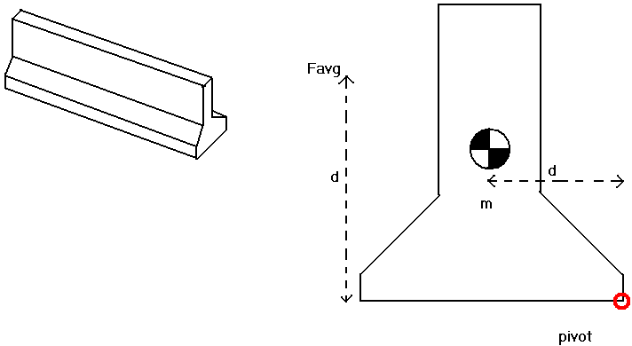

Figure 4. Concrete K-Rail Layout
$\sum{M_{\text{pivot}}}=0$ (eq. 6)
$M=\text{Fd}$ (eq. 7)

6.8 Measurement Devices
As mentioned above, the relevant parameters are vehicle mass, initial and finial velocities, acceleration, contact duration, and crush displacement. Measurement devices must be used to measure all of the parameter with the exception of vehicle mass. The measurement devices include a 5th wheel with a PMDC motor, displacement measuring device, contract switch, and accelerometer.

6.8.1 Velocity
The purpose of the 5th wheel was to obtain an accurate measure of the vehicle velocity before and after the impact. The 5th wheel is designed such that it rigidly mounts to the frame on the front of a 2006 F-150. In order to avoid wheel slip during impact, the 5th wheel has a bicycle shock that provides an adjustable amount of down-force on the pneumatic tire. A unicycle frame and wheel was used for the lower portion of the device and the mounting hardware was built in the machine shop by the team members. A PMDC motor, a Maxon A-Max 26 model 110170, was coupled directly to the 5th wheel shaft. PMDC motor specifications can be found in Appendix C. As the wheel turns, it outputs a voltage that correlates to the tangential velocity of the wheel. A DC amplifier, a ???PartNumber???, with a gain of 10 was used between the data acquisition (DAQ) board and generator in order to collect accurate data with minimal electrical noise. A gain of 10 was used because it provided the largest possible amplification without the possibility of damaging the DAQ board. The DAQ board had a threshold of 10 volts, and a gain of 10 was the largest allowable without fear of damaging the DAQ board. The 5th wheel originally had a shaft encoder to measure wheel rpm, but the design was modified to mount a PMDC motor in order to output an analog signal. The shaft encoder output a digital signal, which proved difficult to synchronize with all of the other analog measurement devices that were being fed into the data acquisition system. Much of the LabVIEW program already written would have to be changed to accommodate a digital input that would have the same time scale as all of the analog inputs. Having a consistent time scale is needed for accurate data acquisition and comparison. If the data points are not recorded on the same time scale, then the digital data would have a different x-axis than the analog data. The PMDC motor was cheap solution to the data acquisition problem since it only costs about $15, as compared to a shaft encoder which retails for about $50. Its shape and geometry also made it easy to interchange with the shaft encoder allowing for minimum downtime to create a new velocity measurement device.
CHRIS D, A PICTURE OF THE FIFTH WHEEL POSSIBLY?

6.8.2 Bumper Deformation
Two methods where used to determine bumper deformation, d. Both methods require the use a deformation measuring device (DMD). Method I consisted of using tin foil rods inserted into the crush cell cavities. Method II consisted of using a displacement measuring device apparatus mounted to the bottom side of the rubber pad, adjacent to the crush cell cavity. Figure 5, below, shows a photo of deformation measuring devices mounted to the A-Bumper.

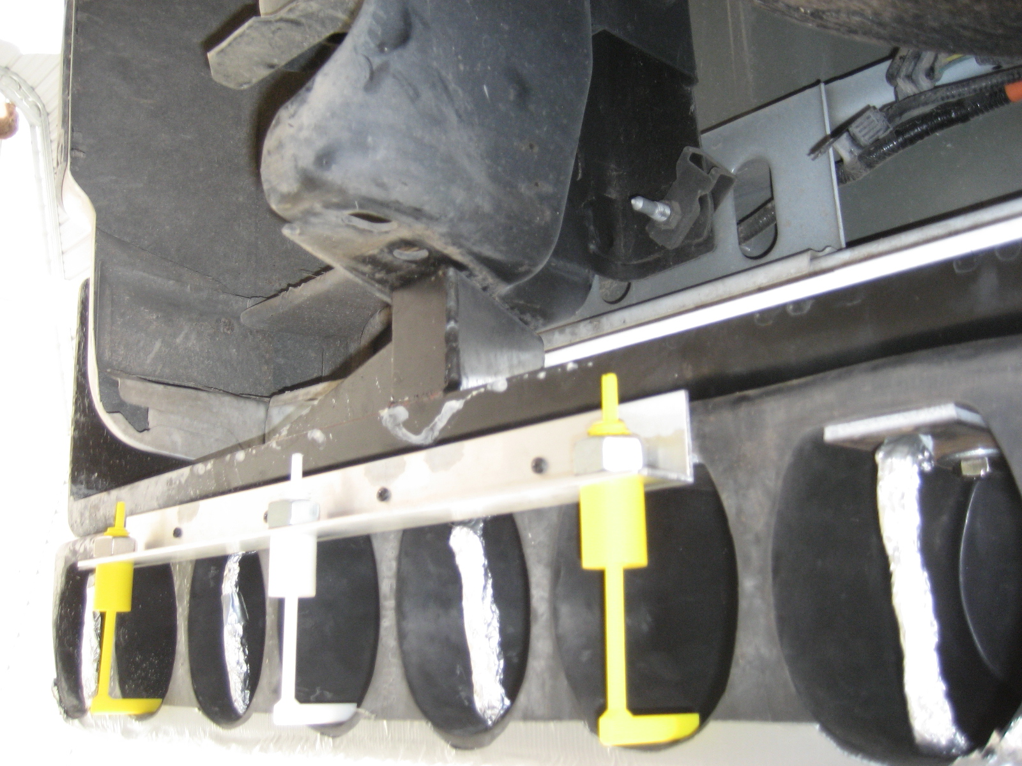

Figure 5. Deformation Measuring Device

Mechanical material response, design practicality, design redundancy, and economic constraints were some of the factors considered in selecting the deformation measuring device (DMD). Justification for the use of this particular DMD design to measure bumper deformation included the mechanical characteristic of the device. This feature is particularly important in determining the deformation characteristics of the A-Bumper. Both devices displayed no deformation resistance upon impact. Another attractive feature of this particular design involved the ability to measure deformation of the crush cell easily. And, if one of the DMD failed during an impact test, data could still be collected using the other DMD. Finally, manufacturing cost of the DMD devices was minimal. A 50 ft. roll of heavy duty aluminum foil was purchased at a price of $3.00. Fabrication of the rapid prototype DMD was free for University of Texas Students.

6.8.3 Impact Duration
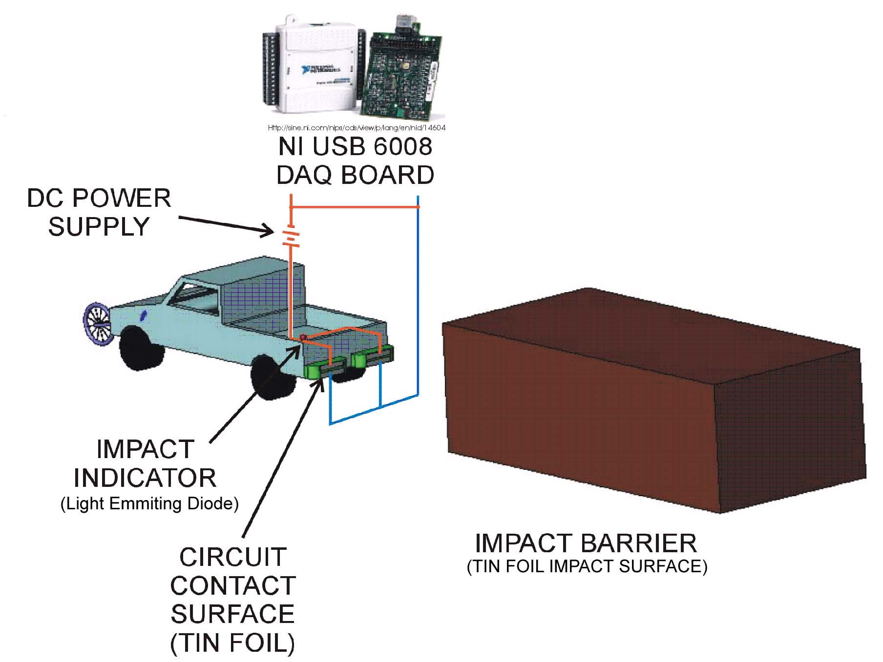
Collision time interval, t, was determined using a simple electric circuit. The electric circuit consisted of covering the A-Bumper with two aluminum foil strips. The foil strips where connected in series with an impact indicator light emitting diode (LED) and two C size batteries. This circuit was then connected in parallel to a National Instruments, Universal Series Bus, USB, Data Acquisitioning, DAQ USB Model 6008, board. The impact barrier was covered with aluminum foil. This constituted the circuit’s on/off switch created upon impact. See Figure 6.

Figure 6. Impact Duration Circuit

Robustness, maximum response time, data acquisition reliability, and economic feasibility were some of the factors considered in selecting the use of the Impact Duration Circuit. The robustness of this simple electric circuit was an important characteristic in selecting this type of design. This circuit exhibited little damage during impact testing. Another feature that contributed to the selection of this design included the response time of the sampling rate. A delay of 0.001 sec. from the DAQ ensured that the time interval reading during impact was accurate enough to use in our analysis of the impact duration. In addition, the ability to verify the operation of the device after every impact proved to be very useful in preparing for the next impact test. This was accomplished by closing the impact circuit and visually verifying that the LED still worked. Finally, the cost of creating the Impact Duration Circuit was kept at a minimum. The DAQ board was loaned to our K-Group by our faculty advisor. Wiring for the circuit was $25. The DC power supply was $10. The price of the LED was approximately $1.

6.8.4 Vehicle Acceleration
Vehicle acceleration was acquired through the use of the Analog Devices ADXL01EM-3 accelerometer. The instrument was mounted beneath the passenger side floorboard of the vehicle. This position was close to the center of mass of the vehicle. If the truck were to oscillate after the impact, the center of mass would act as the pivot point for this oscillation. This means that the front of the truck would fall as the rear of the truck was raised, and vice versa. Thus, with the accelerometer placed in this position, it would be less likely to acquire any extraneous data of vehicle oscillation.
The justification for the use of this method to acquire acceleration included expert recommendation, instrument familiarity, instrument reliability, and economic constraints. AND WE GOT IT FROM THE SAE DOCUMENT Dr. Raul Longoria recommended that we use an accelerometer to determine vehicle acceleration [5]. This is the same instrument we ALBERT, WE CANNOT USE THESE KINDS OF TERMS, BE CAREFUL used during a laboratory exercise to determine acceleration. It proved to be very reliable during our experiment. The accelerometer was provided by our faculty advisor on a loan basis.

6.8.5 Vehicle Mass
Mass (m) was obtained from the weight of the vehicle. The weight of the vehicle is listed on the safety certification label affixed on the inside edge of the driver side door. The mass (m) of the vehicle was calculated from the weight of the vehicle by using:
$m=\frac{F}{a}$ (eq. 8)
where (F) is equal to the weight of the vehicle and (a) is equal to the acceleration due to gravity. ADD MASS OF DRIVER and INSTRUMENTATION

6.9 Data Acquisition Setup
During the impact testing, several parameters needed to be recorded as stated in section 6.3. A LabVIEW program was created in conjunction with a USB Data Acquisition (DAQ) board to collect the velocity, acceleration, and impact duration data during each collision. The DAQ was connected to a laptop so that all of the data could automatically be recorded into a Microsoft Excel spreadsheet. Each of the data acquisition instruments was then calibrated to ensure accurate measurements.

6.9.1 DAQ Board and LabVIEW
A DAQ board is used as an interface between data acquisition instrumentation and a computer. A DAQ board combined with a computer is an effective way to record data quickly and efficiently. The DAQ board used in this project was the National Instruments USB 6008 and was capable of taking 1000 measurements per second. The data sheet for this instrument can be found in Appendix D. This DAQ board was used because it was provided free of charge by the University of Texas and met the data acquisition requirements described in section 4.1.3.
The speed of the vehicle needed to be monitored during the collisions so that the impact velocity could be accurately controlled. The DAQ board and computer setup performs this task well because it can output data to the computer screen in real time, which is another reason why such a setup was used in the project. The easiest way to monitor and record the data coming into the DAQ board is with LabVIEW. LabVIEW is computer software created by National Instruments to be used with their DAQ boards for manipulating incoming data, which is why it was chosen for data acquisition. It was also used in this project because it is provided free of charge by the University of Texas, and each of the team members had experience using the software. The LabVIEW program created for the impact testing was based off of one of the programs already provided by National Instruments in the software named “Cont Acq&Graph Voltage-Int Clk-MINE.vi.” The final version of the LabVIEW program used during the impact testing can be found in Appendix E. Basically, the program would take continuous measurements from the DAQ board at a specified frequency and display them to the screen using a while loop. As it stood, the program would only collect data from one analog input and erase the value after displaying it to the computer screen. This program was then modified to collect data from three analog inputs and store values in a Microsoft Excel spreadsheet as well as display it to the screen in real time. It was necessary to store all of the data in a spreadsheet so that accurate values of velocity and acceleration throughout the impact would be known.

6.9.2 Wiring
All of the data measurement devices were connected to the DAQ board using two conductor shielded wire. Shielded wiring was necessary to ensure as little noise as possible in the electrical signals being transferred to the DAQ. Noise in the measurements would have caused sharp fluctuations in the data and resulted in inaccurate data acquisition.

6.9.3 Instrument Calibration
The PMDC motor, accelerometer, and contact switch needed to be calibrated before beginning the impact testing to ensure that accurate data was recorded during each impact test. Each of the instruments provided a voltage to the DAQ board, which was then sent to the computer, output onto the screen, and stored in the spreadsheet file. Before any of these signals could be useful, it was necessary to find out how their voltage outputs correlated with the respective measurements. In this project, all instruments were used in Differential orientation, as opposed to Referenced Single-Ended (RSE) orientation, to reduce the amount of noise in the circuit. RSE measurements compare the positive voltage input against the ground signal; whereas Differential measurements compare the positive voltage input against the negative voltage input. RSE measurements could produce noise from ground loops [6]. Also, all of the instruments used in this project were connected into analog inputs because they were all analog devices. Such a connection also allowed for each of the three measurements to be recorded on the same timeline, which resulted in easier and more accurate data acquisition and analysis. An illustration of the instrumentation and DAQ connectivity can be found in Figure 7.
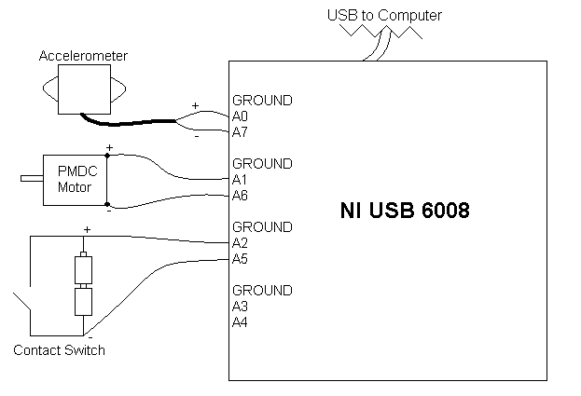

Figure 7. Instrumentation and DAQ Connectivity

6.9.3.1 PMDC Motor Calibration
The PMDC motor was calibrated using an amplifier, cordless drill, reflective tape, and an optical tachometer. The motor was connected through an amplifier and into the second analog input of the DAQ board. Since the motor generated such small changes in voltage (400 millivolts) in the operating range that it was needed for, an amplifier was necessary to boost the output voltage so that small changes in rpm could be more easily noticed and quantified. The amplifier, a ?????, was set to magnify the signal by 10 times. The voltage output of the motor was monitored using the LabVIEW program previously created. The shaft of the motor was then secured in the chuck of the cordless drill. A piece of reflective tape was attached to the rotating chuck handle of the cordless drill so that the optical tachometer could have an accurate position to measure. The drill was then engaged in the clockwise direction and the optical tachometer was held perpendicular to chuck rotation. See Figure 8.

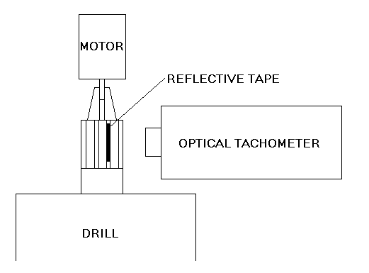

Figure 8. PMDC Motor Calibration Setup

As the drill was held at a constant speed, the rpm of the drill was recorded from the optical tachometer, and the voltage produced by the motor was recorded from the LabVIEW program. This process was repeated for a total of four counterclockwise and one clockwise drill speed. The voltage versus rpm data was graphed to reveal a linear trend. This trend line was then used to convert motor voltage (x) to motor rpm (y). See Figure 9.

Figure 9. PMDC Motor Calibration Graph

The resultant equation was compared against the manufacturer’s specifications, which can be found in Appendix C. This comparison revealed very similar characteristics between the calibrated data and the manufacturer’s specifications as seen below.
Calibration Results at 0.4 Volts:
$$\begin{aligned}\text{RPM}=\text{113}\text{.}\text{97}(0\text{.}4V)−0\text{.}\text{5594} \\ \text{RPM}=\text{45}\text{.}\text{0286}\end{aligned}$$
Manufacturer Results at 0.4 Volts:
$\begin{aligned}\text{RPM}=\frac{\text{1180}\text{rpm}V}{\text{10}}(0\text{.}4V) \\ \text{RPM}=\text{47}\text{.}2\end{aligned}$ *NOTE: Division by 10 corrects for 10x amplifier

Once the rpm of the motor was known at any given voltage, it could be converted to mph using conversion factors. The one relevant data parameter used for this conversion was that the fifth wheel had a 24 inch outer diameter. With this information, the rpm to mph conversion is as follows:

$${\text{Wheel}}_{\text{Circumference}}=1_{\text{rotation}}=πD=π(\text{24})=\text{75}\text{.}\text{398}\text{in}$$
$$\frac{\text{rot}}{\text{min}}x\frac{\text{75}\text{.}\text{398}\text{in}}{1\text{rot}}x\frac{1\text{ft}}{\text{12}\text{in}}x\frac{1\text{mi}}{\text{5280}\text{ft}}x\frac{\text{60}\text{min}}{1\text{hr}}=\text{mph}$$
$$⇒\frac{\text{rot}}{\text{min}}x0\text{.}\text{0714}=\text{mph}$$

So the conversion factor for our fifth wheel was 0.0714 $\frac{\text{mph}}{\text{rpm}}$. These calibration values were integrated into the LabVIEW program to convert the real time PMDC motor voltage to mph. Lastly, the LabVIEW program was manipulated to display the mph in a very large box on the computer screen so that the vehicle velocity could be easily monitored.

6.9.3.2 Accelerometer Calibration
The accelerometer was calibrated using basic manipulation of its orientation. After connecting it to the first analog input on the DAQ board, it was monitored using the LabVIEW program previously created. First, to simulate zero gravitational acceleration, the accelerometer was laid flat and the output voltage was recorded. Then, to simulate +1 g of acceleration, it was placed on its right side and the output voltage was recorded. Next, to simulate -1 g of acceleration, the accelerometer was placed on its left side and the output voltage was recorded. The three data points were collected and graphed to reveal a linear trend. See Figure 10.

Figure 10. Accelerometer Calibration Graph

With this trendline, the acceleration in g’s (y) could be derived from the output voltage (x). These results were implemented into the LabVIEW program such that the acceleration of the vehicle could be easily monitored during the impact testing.

6.9.3.3 Contact Switch Calibration
The contact switch was calibrated used two Duracell C batteries. The batteries were first connected in series. Then, the contact switch, DAQ board, and batteries were all placed in parallel. See Figure 11.
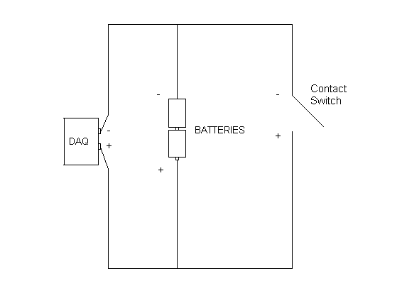

Figure 11. Contact Switch Calibration Setup

After connecting the circuit, the voltage into the DAQ board was recorded at 3.04 volts. Then the contact switch was disconnected and the voltage into the DAQ board was measured at 3.13 volts. Thus, when performing the impact tests, the bumper would be in contact with the barrier when the third analog input read 3.04 volts and not in contact when it read 3.14 volts. This information made it easy to identify the impact duration in the each of the collisions.

6.10 Impact Testing
The low speed vehicle collision impact test was conducted on Saturday, July 15, 2006 from 9:00 am to 6:00 pm. A total of seven (7) low speed impact collision tests were conducted.
- A-Bumper impact test at 1 mph collision with a flat barrier surface.
- A-Bumper impact test at 2 mph collision with a flat barrier surface.
- A-Bumper impact test at 3 mph collision with a flat barrier surface.
- A-Bumper impact test at 4 mph collision with a flat barrier surface.
- A-Bumper impact test at 5 mph collision with a flat barrier surface.
- A-Bumper impact test at 1 mph collision with a 4” diameter pole.
ALBERT: DO you want to mention that we did a 2MPH pole test?
- Stock bumper impact test at 1 mph collision with a flat barrier surface.

The justification for this type of impact test includes constraints provided by our sponsor (HDC, Inc.), analytical analysis requirement, availability of resources, and proven expert methodology. One of the main constraints required by our sponsor included various impact tests at prescribed velocities and with different barrier types. Another constraint included providing appropriate data for a thorough analytical analysis of the A-Bumper. In addition, another constraint for this type of impact test included the use of only one vehicle. Finally, previous methodology that closely resembled our project scope, provided by an SAE study [2], reaffirmed our approach for conducting this type of impact test.

6.11 Data Collection
Deformation, d, was determined using calipers to measure un-deformed crush cell length, L, before impact. Figure 12 shows the un-deformed crush cell length, L. The displaced length, x, was determined with the use of the DMD apparatus, after impact. Figure 13 shows deformed crush cell length x. Displacement, d, was calculated by subtracting length x from displacement L to determine deformation, d.

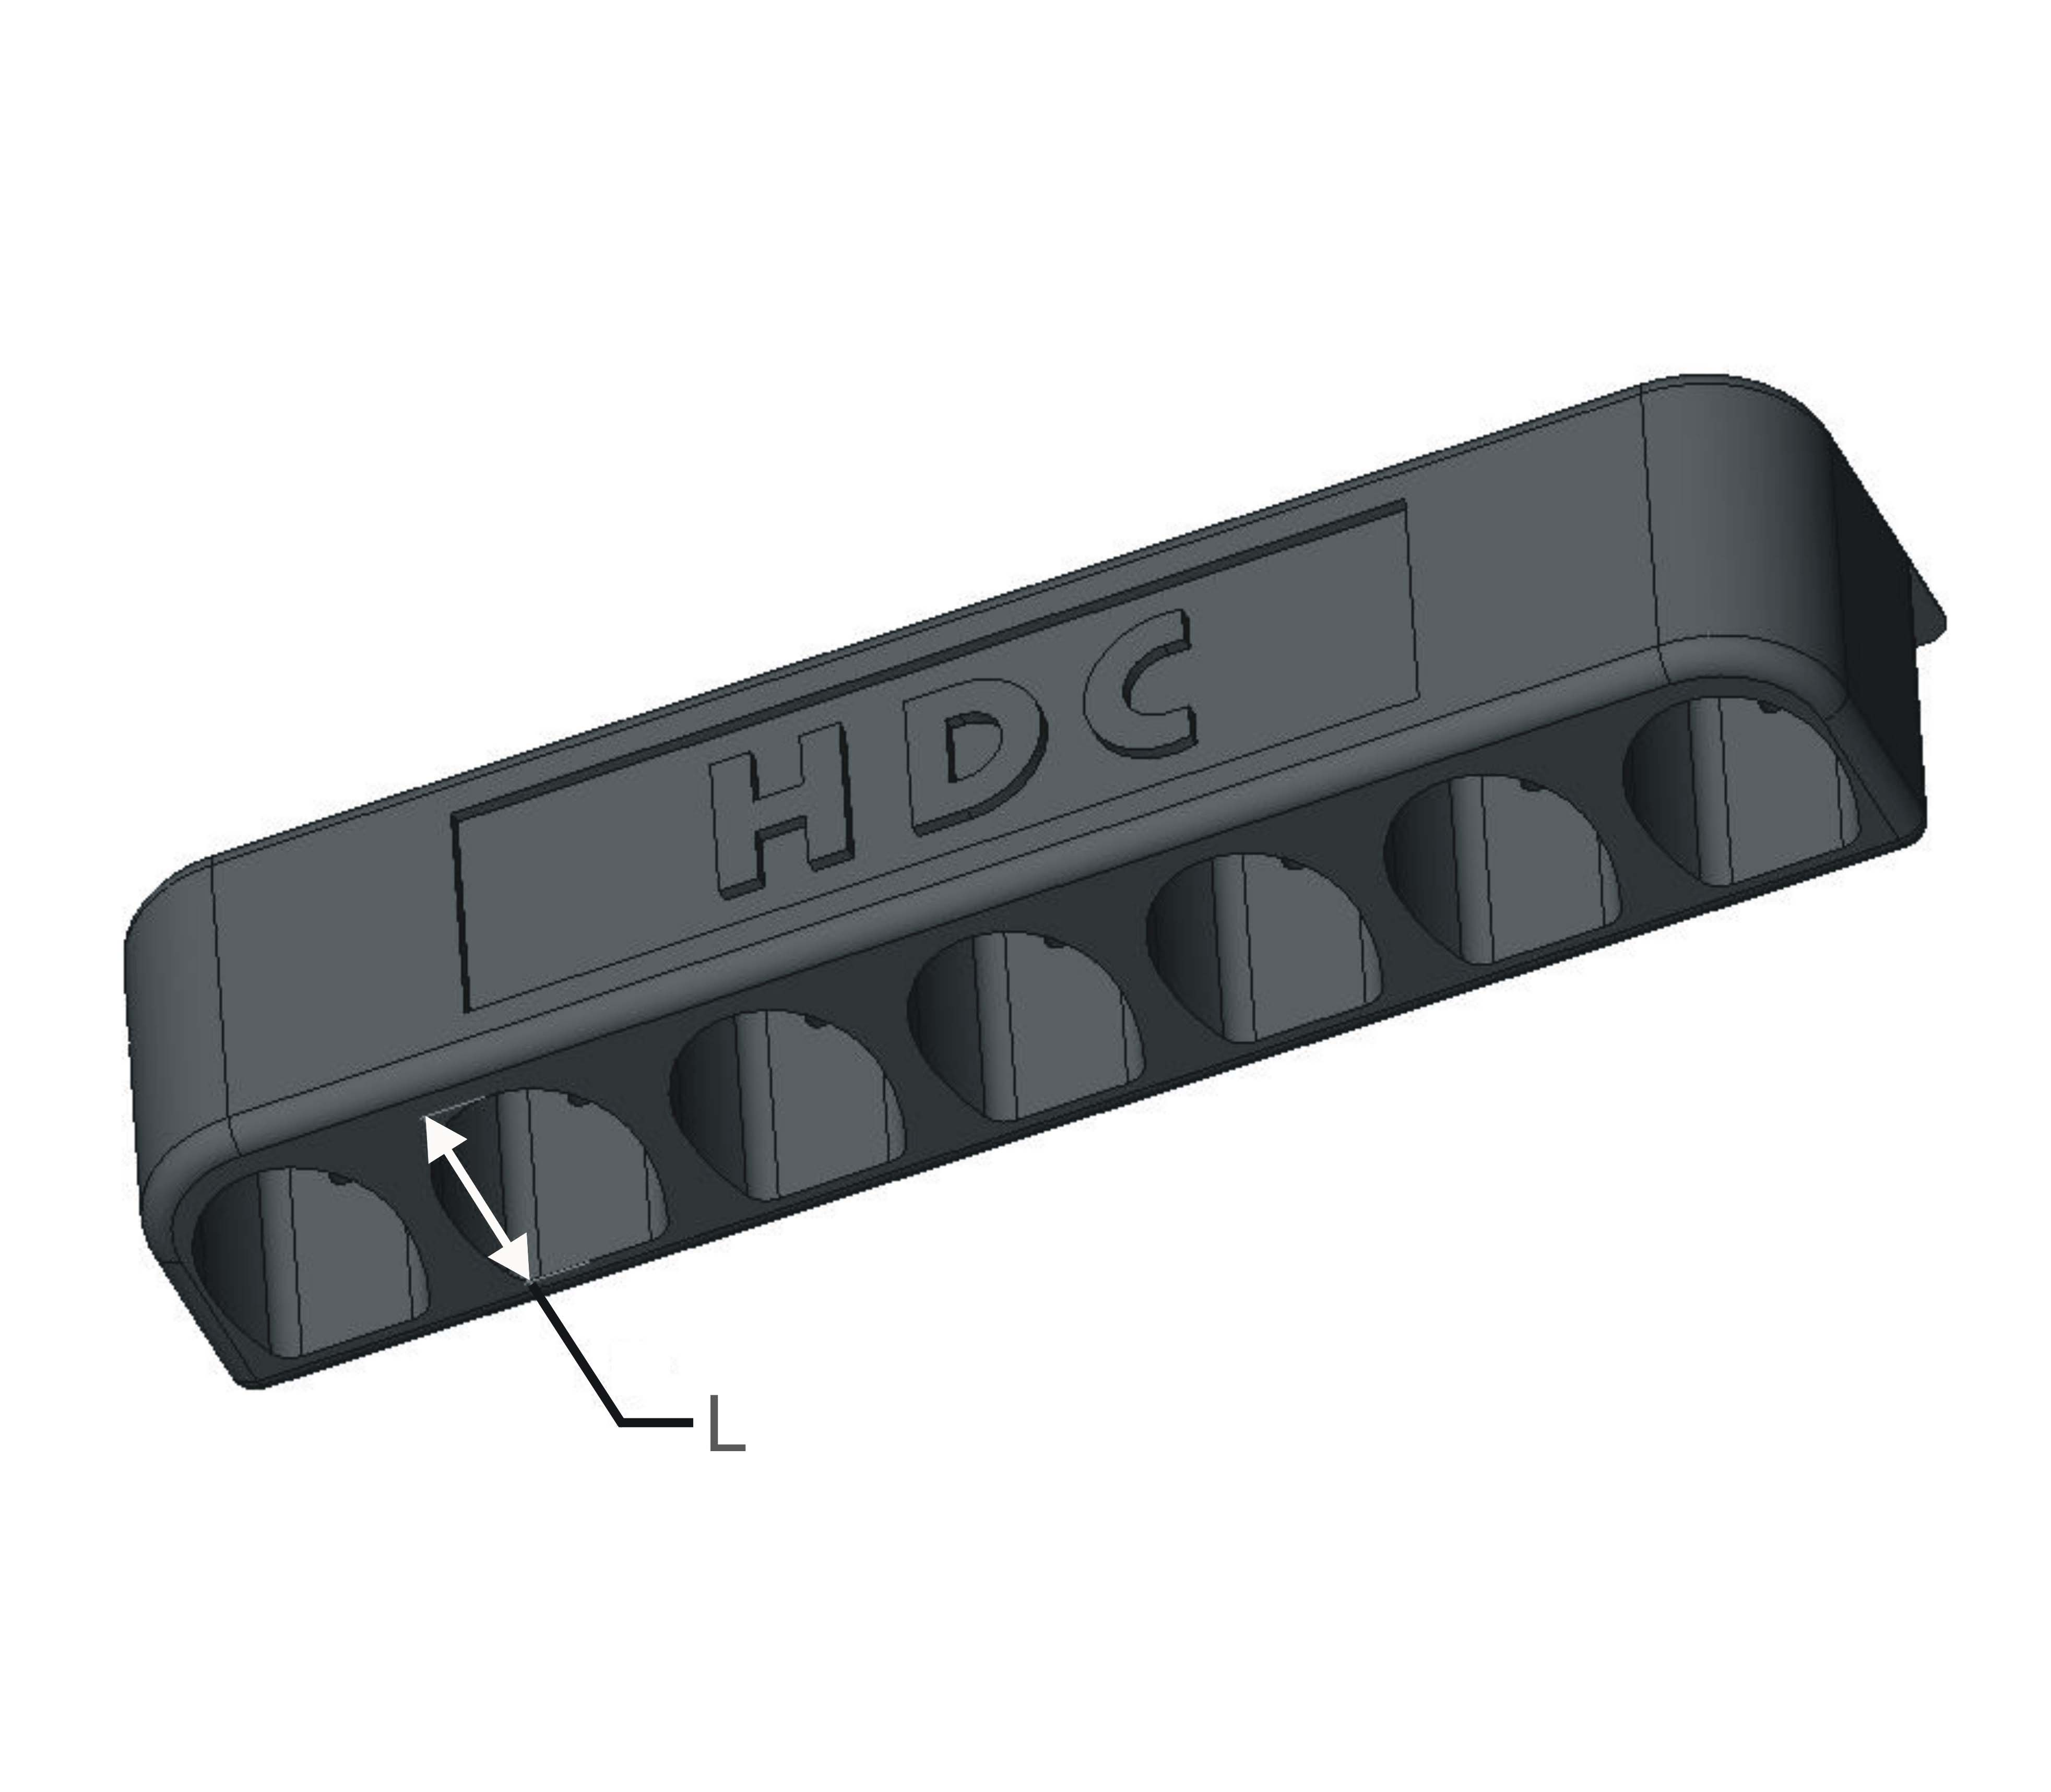

Figure 12. Un-deformed A-Bumper
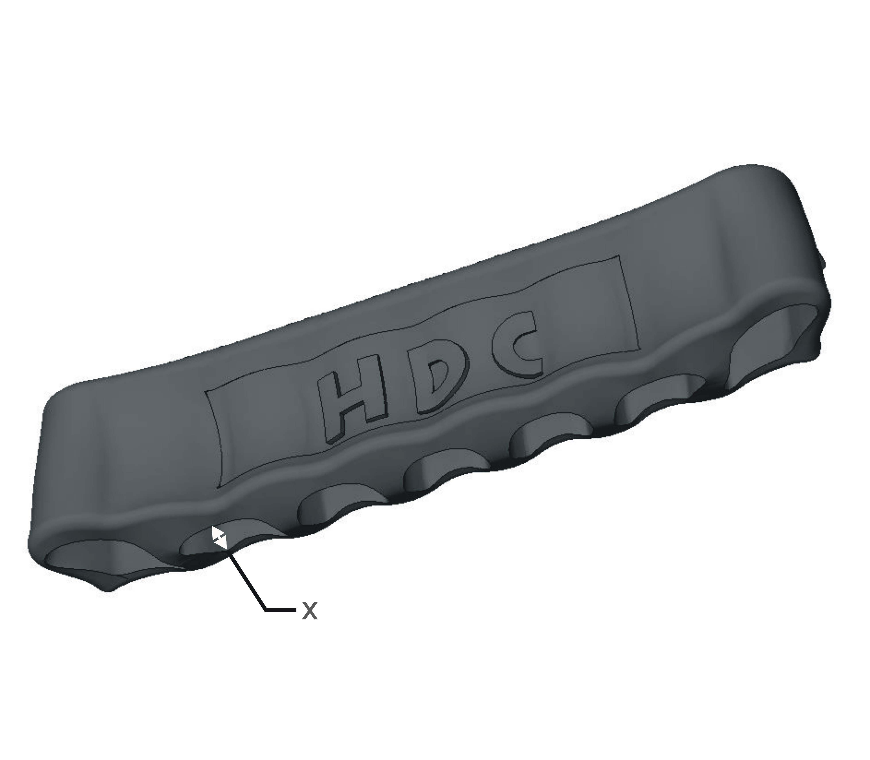

Figure 13. Deformed A-Bumper

Duration of impact, t, was determined with the use of an electrical current interval sent to DAQ board upon impact. Electrical current intervals were used to determine duration of impact. In addition, illumination of LED’s will be used to synchronize impact video with acquired data during the analysis phase of the project.
Acceleration (a) was acquired with an accelerometer connected to the DAQ board. The DAQ board was then connected to a lap top computer for instrument data recordings.
All experiments where recorded using regular speed video cameras. Three (3) cameras were positioned at different locations during impact testing. For a close-up of the overall profile of bumper and barrier, camera #1 was affixed to a pole at a distance of approximately 2 ft. from both vehicle and barrier. For a close-up bottom view of the barrier and bumper impact, camera #2 mounted on a tripod and pointed to a mirror which reflected the crush cell behavior during impact. Camera #3 was positioned approximately 5 ft. above the edge of the barrier to record the angle of vehicle impact and the deformation of the bumper. See Figure 14.
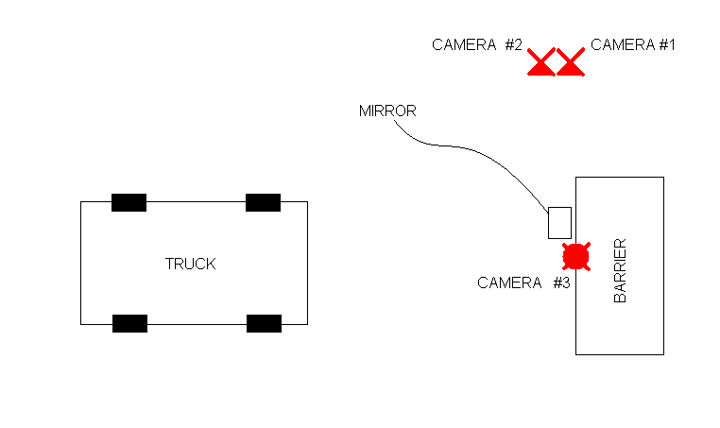

Figure 14. Video Camera Placement

7. FUTURE WORK
The majority of the project is now complete and the remaining tasks can be found in the following sections. A Gantt Chart is located in Appendix F that outlines the entire project and the progress to date. The remaining tasks include:
- Cost Analysis
- Data Analysis
- Material Research
- Analytical and Predictive Modeling
- Data Interpretation

7.1 Cost Analysis
A cost analysis will be performed that displays how much it cost HDC, Inc. to complete this project in the 2006 summer session and how much it would cost to reproduce this project without University of Texas at Austin sponsorship.

7.2 Data Analysis

7.2.1 Parameter Summary
The data collected during the crash testing will be analyzed to determine impact characteristics of the A-Bumper and the stock bumper of a 2006 Ford F-150 pickup truck. The parameters used to determine this effectiveness include the energy dissipated, the peak acceleration, and the amount of deformation of the bumpers. The analysis of these parameters will allow for the effectives of each bumper in protecting the vehicle in an impact to be determined.

7.2.2 Energy Dissipated
$\frac{1}{2}{\text{mv}}_{1^{2}}−\frac{1}{2}{\text{mv}}_{2^{2}}=\text{EnergyDissipated}$The amount of energy dissipated in the collision will be calculated through equation 9.
(eq. 9)

The energy dissipation equation uses the kinetic energy of the vehicle just before and after collision with the static barrier. By subtracting these two values, the energy dissipated by the vehicle is determined. The energy dissipated will be a result of permanent deformation, friction, heat, and noise produced from the collision in the bumper, vehicle, and barrier. The A-Bumper will also provide energy dissipation during its elastic deformation. Correlations will be made to relate collision performance with energy dissipation.

7.2.3 Peak Acceleration
The accelerometer used in the experiments will provide acceleration data that occurs in the collisions. The peak acceleration is one value that is of high value because it defines the maximum shock that is a result of the collision. This value is useful because characterizes how violent the impact was by showing the rate in which the vehicle was forced to decelerate. This data could provide insight to vehicle damage as well as the likelihood of injuries to occupants of the vehicle.

7.2.4 Impact Force
$F_{\text{impact}}=\frac{{\text{mv}}^{2}}{2d}$Impact force will be calculated using the velocity (v) of the vehicle just before impact, its mass (m), and the max displacement (d) measured during the collision using equation 10.
(eq. 1)

The maximum displacement of the bumper correlates to the distance traveled by the vehicle before it reached a zero velocity. The impact force is the maximum force that the bumper is subjected to during the impact. This force will be used in conjunction with bumper geometries to determine if the bumper or mounts will be permanently deformed.

7.2.5 Video Synchronization
Videos of each impact test were recorded along with the data stream from the instrumentation. The videos will be synced with the data stream so that visual correlations of the bumper behavior and data samples can be further analyzed. This analysis will be useful in determining the deformation behavior of the bumper when it is subjected to the different impact scenarios. The results of this analysis may lead to design suggestions for the A-Bumper.
The video syncing will also allow for the performance of the bumper to be visualized and communicated to HDC Inc. and their customers. Side by side comparisons of the A-Bumper and the stock bumper can be used to visually demonstrate the differences in performance.

7.3 Material Research
The A-Bumper is currently formed out of ethylene propylene terpolymer (EPDM). The material properties of this compound have been researched to determine if the material is capable of withstanding a 10 year service life.
Initial research indicates that EPDM possesses above average resistances to most environmental factors it will experience. This material has been used in the roofing industry for many years to act as a weatherproof membrane. The service life of the material in this application has been reported to be in excess of twenty years [7].
HDC, Inc. wishes to reduce the costs as much as possible while retaining a 10 year service life. Future research will be conducted on alternative materials to determine if a less expensive solution exists through either cost of materials or manufacturing.

7.4 Analytical and Predictive Modeling
An analytical model of the A-Bumper will be developed to predict the behavior of the bumper in different collision scenarios. To formulate this model, data will be obtained by applying static loads to the bumper and measuring deformation. This data will be used to determine the structural and material behavior, such as the spring constant, under various loading conditions. These characteristics can be used to predict the behavior of the bumper when subjected to various loadings scenarios. This model will also help determine the maximum allowable forces which will defined by the maximum allowable deformation that will offer effective collision dampening. These loadings can then be used to suggest maximum vehicle velocities and masses in which the bumper will remain effective at protecting the vehicle from damage during a collision.

7.5 Data Interpretation
The engineering analysis will be conveyed in two different levels of technicality. A technical level will be geared towards purchasing engineers of firms that own fleet vehicles. This technical interpretation will consist of figures, methods, and detailed conclusions of the A-Bumper’s performance in the impact tests. The consumer level will provide an overall summary of the A-Bumper’s performance. The conclusions will be summarized in a more simplistic manner and will provide the consumer with percentage based differences in behavior and cost benefits. The data interpretations will allow HDC Inc. to provide the information that these two customer bases would find useful. This will ultimately allow HDC Inc. to better sell their product by providing more information to customers than they would normally receive when choosing a bumper.

8. CONCLUSION

8.1 Final Remarks
The low speed impact test and analysis of the A-Bumper, sponsored by HDC, Inc., was one of many senior design projects offered for mechanical engineering students at The University of Texas at Austin in the 2006 summer session. The project was executed by Chris Delzell, Jeff Dieterich, Chris Kuryak, and Albert Martinez. The A-Bumper project has been a culmination to all of the knowledge gained throughout the University of Texas at Austin Mechanical Engineering program.
REFERENCES
1. HDC, Inc. “Web Catalogue,” 10 June 2006 <http://www.poplocks.com/Graphics/Index/Web_Cat_05d.pdf>
2. Happer, A. J., Hughes, M. C., Peck, M. D., Boehme, S. M., 2003, “Practical Analysis Methodology for Low Speed Vehicle Collisions Involving Vehicles with Modern Bumper Systems,” Accident Reconstruction 2003, Society of Automotive Engineers International, SAE SP-1773, 2003-01-0492, pp. 77-91.
3. Kaufmann, Maria. “Best of the pickup bumpers isn't even fair.” Status Report 4 Apr. 1998: 4-5. www.iihs.org. Ed. Kim Stewart. IIHS. 14 June 2006 <http://www.iihs.org/sr/pdfs/sr3303.pdf>.
4. Otto, K., Wood K., Product Design (1st ed.). (New Jersey: Prentice-Hall Inc. 2001).
5. Personal Communication with Raul Longoria, Professor, Department of Mechanical Engineering, The University of Texas at Austin, June 28, 2006.
6. Personal Communication with Raul Longoria, Professor, Department of Mechanical Engineering, The University of Texas at Austin, July 13, 2006.
7. DuCharme, Michael. “The EPDM Roofing Association makes headway in research and communication.” March 2005 www.professionalroofing.net. <http://www.professionalroofing.net/article.aspx?A_ID=608>.

APPENDIX A: Mind Maps
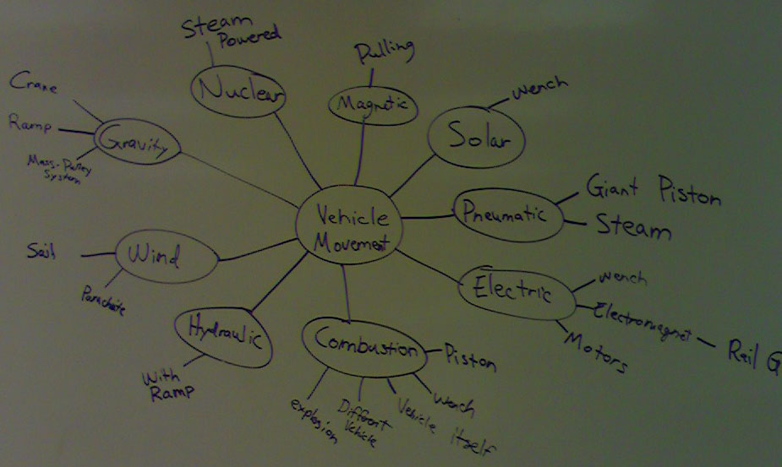
Mind Map: Overall Vehicle Movement

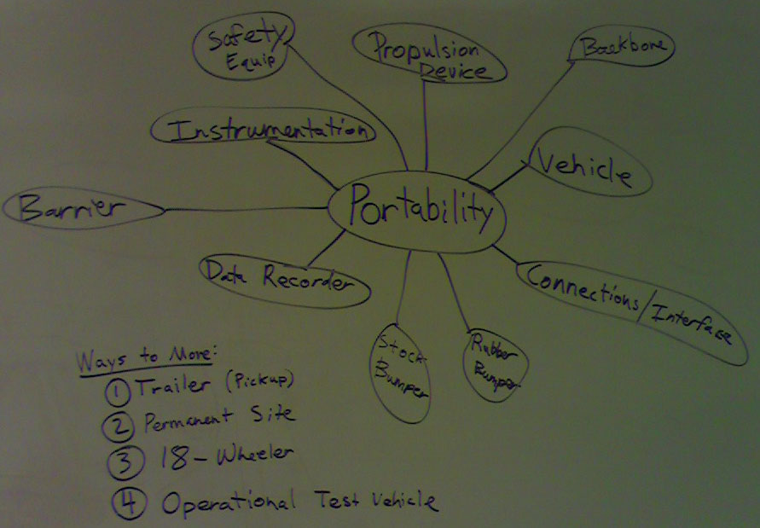
Mind Map: Transportability
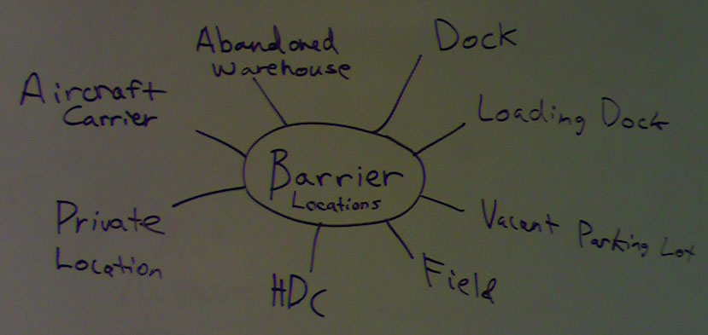
Mind Map: Barrier Location

APPENDIX B: Concept Selection

Concept Selection: Impact Duration

APPENDIX C: PMDC Motor Specifications

APPENDIX D: DAQ Board
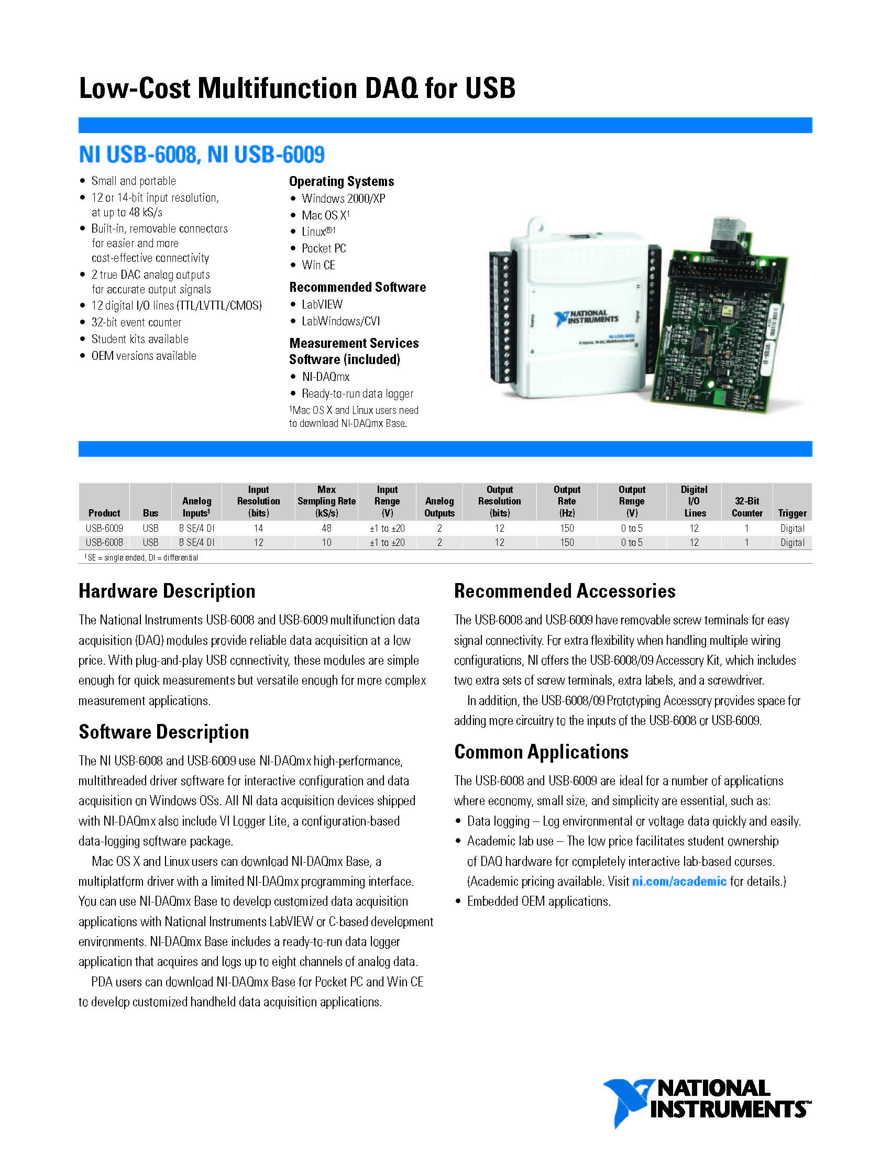

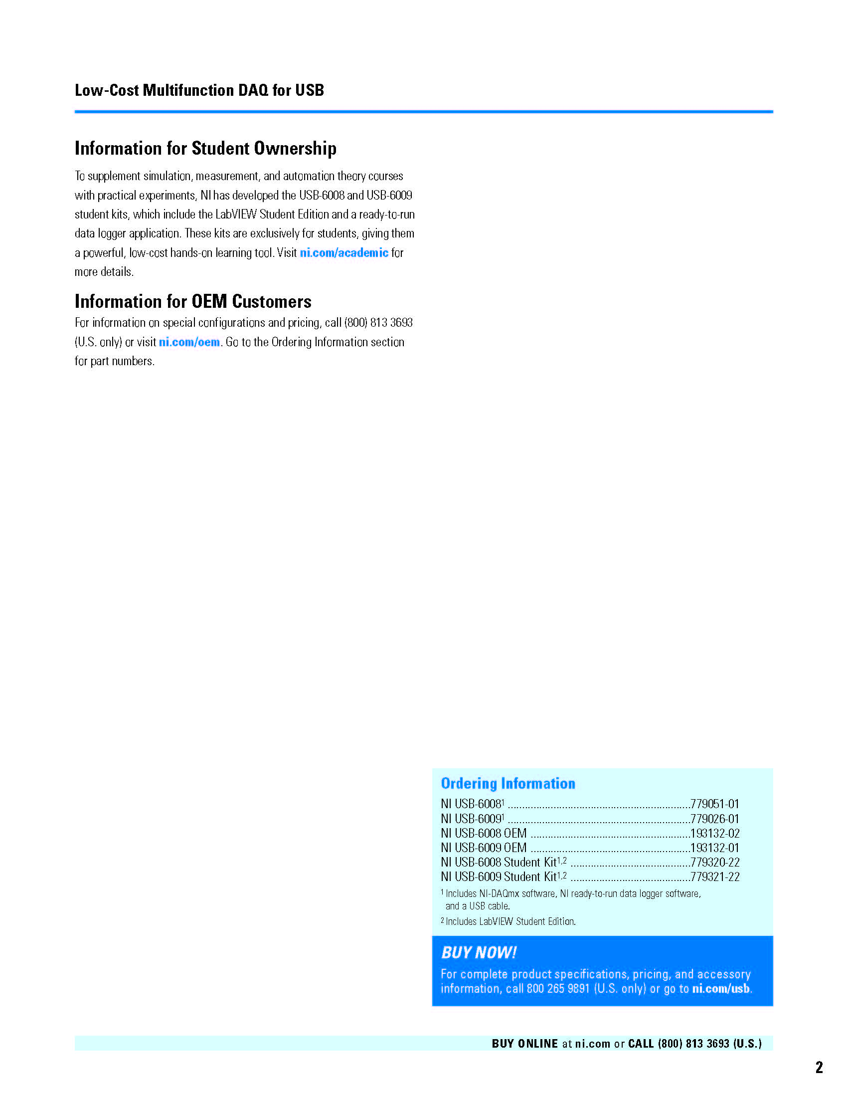

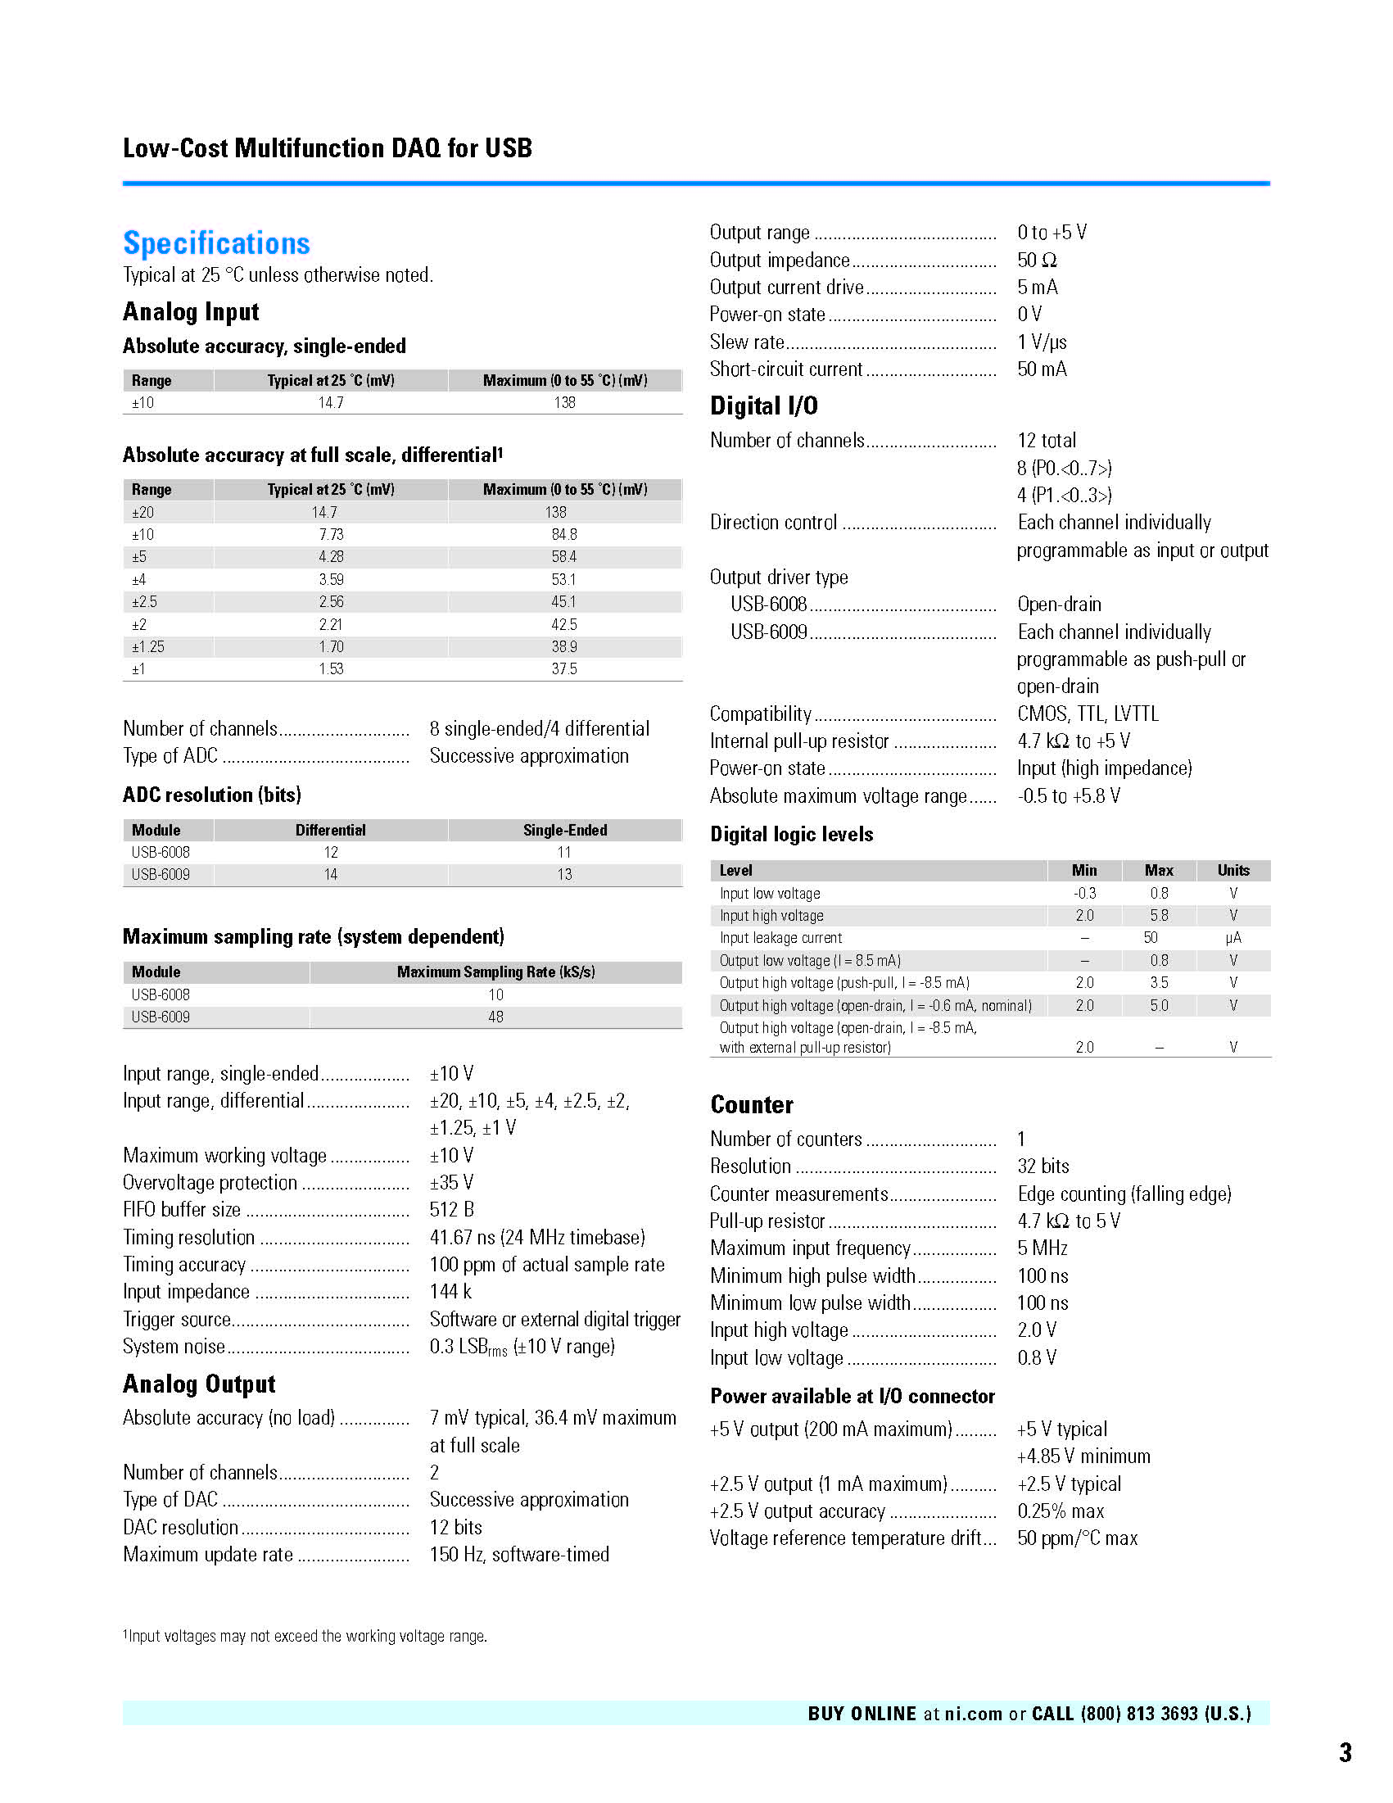

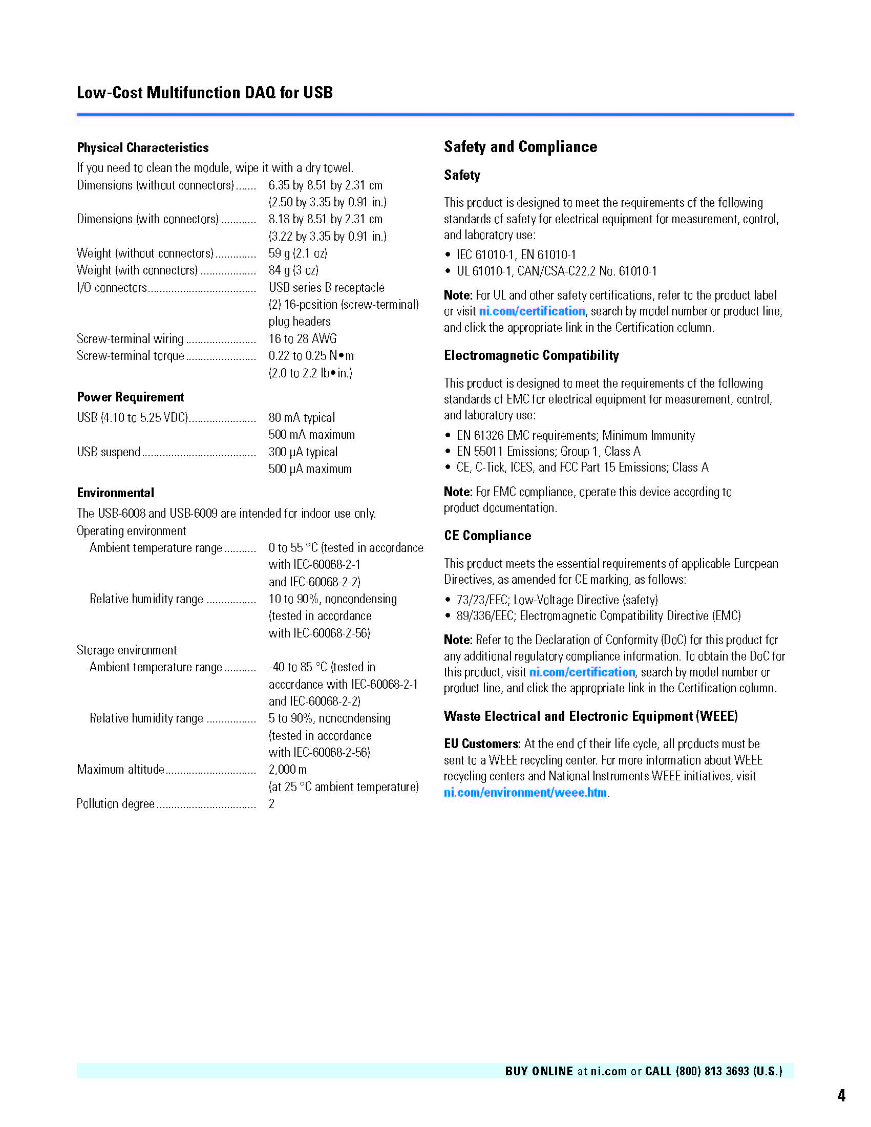



APPENDIX E: LabVIEW Program

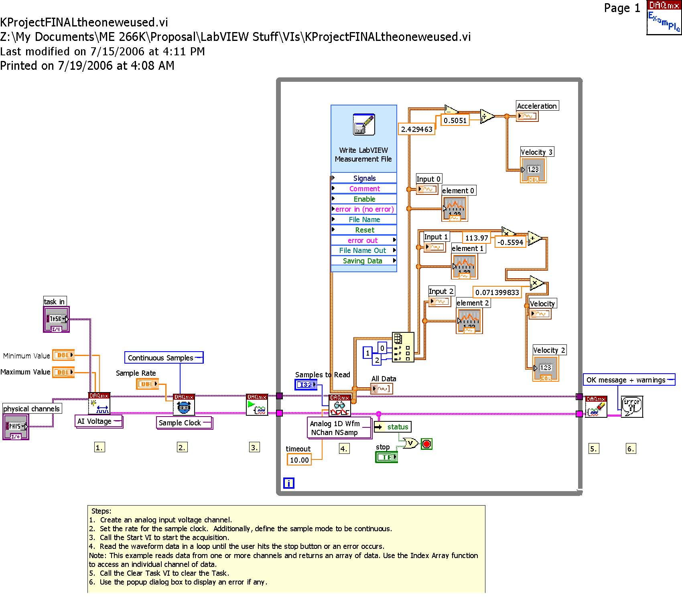

LabVIEW Program: Block Diagram

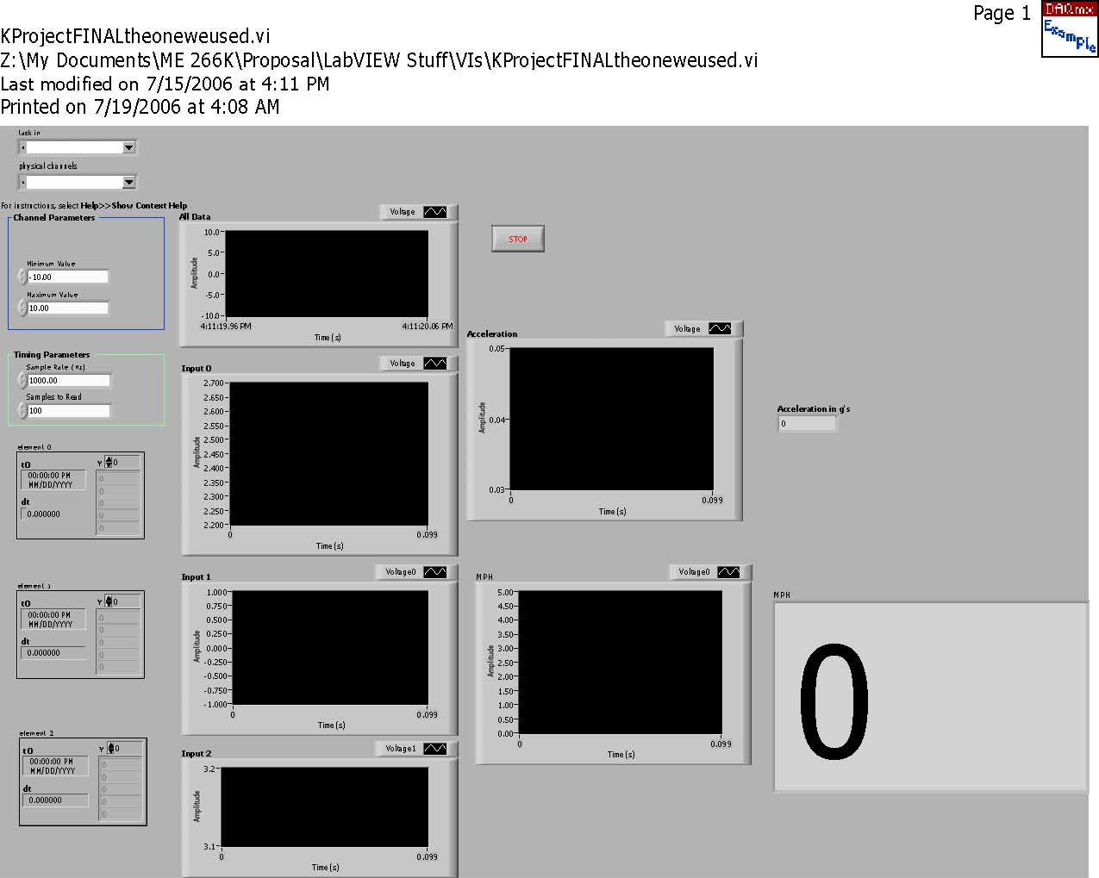

LabVIEW Program: Front Panel

APPENDIX F: Gantt Chart
