Preface

"A cyborg is a cybernetic organism, a hybrid of machine and organism, a creature of social reality as well as a creature of fiction."

- Donna Haraway, A Cyborg Manifesto

Cyborg is a word with which some people might identify; others might feel alienated, and still others largely ignorant. The Cyborg to which I refer in this report follows the tradition of Donna Haraway's Cyborg Manifesto. While Haraway focused on feminist theory and practices, I will take a more general interpretation of the term and look at how the “Other” interfaces with science, technology, and media in order to create change. Specifically, I will look at how the “Other” might use digital technology and interfaces to bring about change and upward mobility in terms of social, cultural and economical capital. The idea of capital comes from Bourdieu’ s (1984) Distinction: a social critique of the judgment of taste. The Cyborg’s ability to harness different forms of capital through the use of newfound tools signifies a seemingly new way of creating change (what kind of change are you talking about? Open source or activism?). For my purposes, the construction of the Cyborg is not limited to the character of its physical body, but to the apparatuses with which it interacts, such as network systems, wired, wireless or unknown (what does “unknown” mean?).

What is a personal media system? (Introduction)

The objective of this project is to take an in-depth look at how multimedia production is implemented within the confines of a cyborg's Personal Multimedia Production System (PMPS). On a physical level, a PMPS consists loosely of media input, processing and exportation tools. On a production level, a PMPS should give the Cyborg the ability to create, innovate and distribute ideas with ease and in on a scale usually only available to large conglomerates. Below are some questions I pose for the report:

Why does a Cyborg need a personal media production system?

How do I go about setting one up?

Does this multimedia prosthetic make the cyborg stronger?

In the movie Hackers the degenerate protagonist dreams of having software and hardware truly capable of social, cultural and economical change. He accomplished this feat through not just software and hardware, but also through the making of a bond with like-minded hackers and though the merging of his virtual abilities with the flesh.

How Personal Multimedia Systems interface with the Cyborg (Part 1)

What does it mean to create today? How does what we create live on? Great ideas have influence, but how do we influence great ideas? How do we make what we are? How do I use my hands to change the world?

Cutting deep into the subconscious can be a tricky thing. The subconscious, in regards to this report, is the part of the mind that lays between the conscious and the unconscious, where the logical merges with the imagined in order to create (create what?). Some cyborgs may break through with silence; others with white noise and some with complete chaos. Someone who meditates to find his inner thoughts and to explore, transform and grow is discovering the subconcious; so might be someone who sits and listens to music, or watches TV, or writes in order to find his relationship with his subconscious.

My method is working on my computer, typing while watching influential videos, observing instant messages and letting the logical be processed and my imagination merge the data I am processing into creativity (figure 1). Through my cybernetic relationship with my machines, I have a way of harnessing creativity that requires, not looking, not feelings, but flowing thoughts into digits. That is, the way in which my mind begins to process logical understanding heavily takes into account digital interactions with my PMPS.

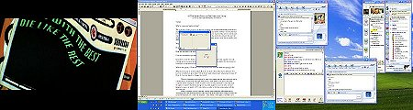

“So there a thought has been made, a moment has been had, blood rushes through my body; and thoughts of how a multimedia system can change one’s perspective on creativity begin to tear through me.”

Others experience this phenomenon as well; during my case study I have seen how “hackers” have similar experiences with their multimedia systems. Within the field of radio, television, and film, similar experiences might take place during audio/video editing sessions. The expression of thoughts into physical objects is something we have been doing for a long time, but not until recently have we had so much opportunity to create with such complex devices. Our tools are what we have to connect us to our world. Our eyes let us see, our nose smells and our ears hear; but what about our cybernetic extensions? How are we affected by the marrying of the flesh with the digital?

Reaching our full creative abilities is possible when one harnesses the subconscious. This idea is proved when listening, tasting, smelling not with our senses, but with the subconscious. Sex, eating, and the intake of media can have great effects on our state of mind, on our state of being, and on our ability to create.

A subconscious connection with a PMPS endows the user with the ability to have a more intimate relationship with one’s creativity. Tame examples include the creation of consumables through the act of digital manipulation, like AutoCAD, scientific food research or flash animation. A PMPS extends the limits of our physical ability, creating a streaming of our subconsciousness in ways that might not be otherwise available.

So how do we create these systems? How do we use them? These questions can only be answered with the scouring of our mind and soul. The uses are what you want them to be; the creation is where you can guide the use.

The creations of such systems found in my project were not complete streams of consciousness, but acts of desperation of the subconscious; acting on the need for flexibility, identity and exploration. In the project, the “basic example” I give may look like it is set in stone, stating, “this is the way one must start,” but one may choose to start with a notepad, pen and phone. The creative aspirations of Cyborgs start with their interests, but their interests can change, just like their systems do. Examples of such changes are when one switches from film to digital photography or from car hacking to PC (hardware) hacking. Another example may be an engineer who uses Linux (an opensource operating system) to run computations by day and at night runs a community pirate radio station.

The tools change, the workflow changes; but does the output change? This is up to the user. Do we change the way we output when we change the methodology of our work? For instance if one never shoots with an analog camera, does this negatively affect his ability as a digital photographer in general? The transition to new tools and workspaces might seem trivial to some, but to others it might be what makes their aesthetic unique. A good example of this is someone who does Kirlian photography, a technique that uses electricity and Polaroid film to create exposures. The re-appropriating of our ideas is key to reaching our subconscious.

Web Hosting (Part 2)

Some proponents of technology might believe digital tools are overrated, but for social, cultural, and economical movement within our society it is quickly becoming apparent that digital tools, combined with knowledge and training, can in fact create ways for one to overcome boundaries once thought impossible to break through. Examples are numerous, but technologies such as inexpensive web hosting have given the Cyborg the ability to gain capital not only technologically but also socially, culturally and economically.

A look at web hosting experience

In this section we will take a brief look at web hosting and how it has changed over the past few years. Web hosting is a service that allows a user to have server space at a data center. 1and1.com, a web hosting company, began an initial push for web hosting by advertising a free three-year subscription hosting to the general public. These subscriptions included web space (500mb), a domain name, URL, email account and a host of web tools (SSH, MySQL, SSL) accessible through any web browser. The expandability of the service is quite interesting, for example as of this writing they offered a business hosting package that offers all of the stated above, along with more space, domain names and other features for ten dollars a month.

How and why does this matter? Before companies such as 1and1.com, the Cyborg had to buy a physical server or remote location service in order to have web space on the Internet, which would cost any where from two hundred and fifty to thousands of dollars a month. With the new lower barrier to entry the Cyborg can create his domain name, administer email, and create websites for others, all for prices that used to buy a 10mb email account in the 1990’s.

This has changed the Cyborg’s ability to create content as well as how they distribute it. They now have the ability to look much bigger then previously possible. This might have been possible before through the use of graphical aesthetic, i.e. making your website look “corporate” through using tools such as Macromedia’s Flash. With services like 1and1.com, a small group, such as someone trying to create a social forum for discussing local events, can now create such a website without having to apply for huge grants for web hosting, training, and administrating; but just click a couple buttons on a webpage and in minutes have a professional site ready to disseminate information. For illustration purposes below is a screen capture of the 1and1.com’s interface.

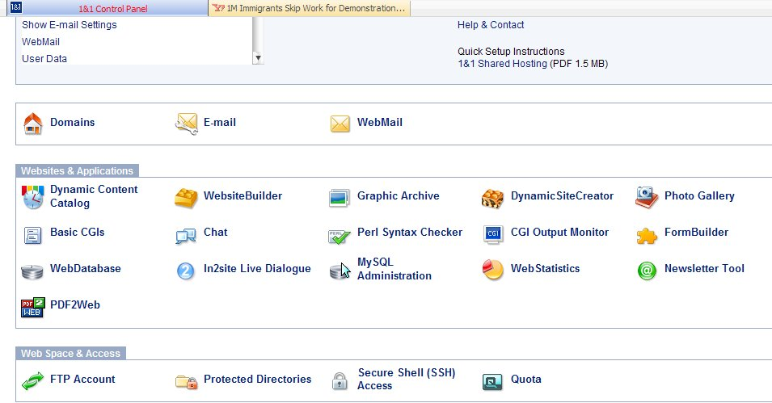
1and1.com’s Control Panel

1and1.com’s control panel is truly an intuitive interface. Features such as the DynamicSiteCreator and the WebStatistics feature have changed the methodology for creating cutting edge websites within minutes.

“So now we can breath right? All is free?”

The overcoming of physical limitations is thus accomplished by digital manipulation combined with subconscious know-how. Because of augmented abilities through which to channel the imagination, new ways to be creative have developed. Cyborgs fight hard to break down barriers to creative expression, and it appears that they have succeeded.

Well, not so fast,.Our technical know-how is not something created overnight, nor is it easily learned or cultivated. The Cyborg must go out and be educated.

The purpose of the ACTLab Project: A look at Personal Multimedia Production Systems, was to look at the cutting edge, to see how systems are being innovated and pushed to their limits. A PMPS system is ever-evolving; it should have the ability to naturally grow with you.

So how does a Cyborg attain such a relationship with a PMPS? This is a question I have always asked about many topics. Some people say “google” (the term of the week?). I say through thoughtful thinking, as well as paying close attention to social and cultural cues. These cues are how we learn about our world in general; let them be how one finds out about the Cyborg’s relationship with PMPS. The way in which you find how your relationship will be with a PMPS is much how you find your relationship with other tools, whether it is a paintbrush, a camera, or mechanic tool set. Attention to the artistry, the science, the methodology is key.

From Analog to Digital (Part 3)

How a Cyborg conceptualizes itself within the realm of the PMPS is important. The dimensions we add to our identity with a PMPS should not be ignored. The PMPS brings a new way to identify our cyber-self, a new way to connect and interact with others, both physically and virtually.

How we think about the way we interact with our PMPS has a large effect on its use. These systems are where we go from the physical to digital world and back. From analog to digital is an act that is often blackboxed in such a way as to make it seem to be natural, as if we were built to convert to digits.

The walk in analog, the thoughts in digital

One afternoon as I wrote this report I decided to take my thoughts on the road. As I walked I recorded my thoughts, my angles, my ideas, with a digital camera, all the while taking in the sweet tunes of Nine Inch Nails. Through the turbulent emotions I was experiencing, my digital camera took over, turning me into its specimen, my surroundings its object of submersion. This extension of the body took me to where my subconscious lay.

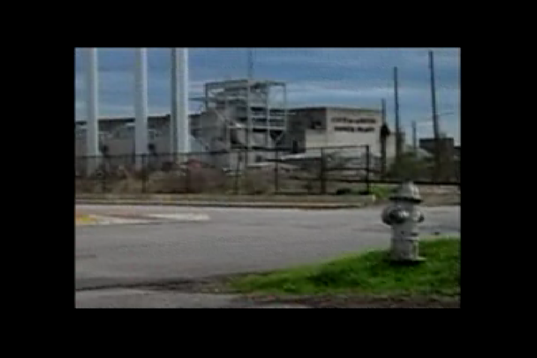
Here is a screen capture from the walk

Does using the camera as an extension of the body show new parts of my identity? This spiral into whether what we are seeing is reality or virtual should be examined. How is this digital representation real? The transition from the analog to the digital world is one that feels like an eternity, in that until one has their thoughts digitally stored they may feel as if it really didn’t happen as their brain is the only documentation of such an event. But it may end when the next extension of our cybernetic body matures. It will be interesting to see how will these new extensions open our minds.

How to use a PMPS

The uses a PMPS brings to a cyborg are many. One is the ability to distribute one’s thoughts globally. In the 20th century it was a very difficult task to disseminate your ideas freely past your geographical realms. Control over such content had a great potential to become distorted through the analog degeneration of the message.

This raises the question of whether the PMPS is a worthy tool of the social activist. If so how much effect can it have?

This is a hard question to answer because there are many external influences on how one thinks of their PMPS. However, if one can start to look at how they can use their PMPS for social, cultural and economical cultivation, the ability to gain capital in these respective fields can improve greatly. Many times this cultivation is taken for granted. Some of the simplest cultivations may be looking up information on the Internet or contacting others through email. Other cultivations include creating websites to disseminate information, making web forums for open discussion, or using the Internet to transfer/exchange data, such as software, music, video, and images. Many times this last topic of software, music, video and images are thought to be a pirate-infested land. I argue that legitimate dissemination of multimedia is now possible through the Internet because of such actions, meaning that because of the pioneering technologies used by Internet pirates, the ability to legally distribute media has become easier.

The ACTLab server is a testament to this declaration by means of the way it provides new and creative content. The ACTLab server allows for cutting edge research to be viewed by the pubic in a way that few other programs allow. Past and current projects from the labbies are all documented and presented; ideas are expressed and room for interpretation flourishes. Even this report is available on the server as it is created!

Another example of legal dissemination of multimedia is someone who uses his or her DSL/Cable (also known as broadband) connection as a portal for hosting a web server. Such practices are not uncommon. For example with Apple’s OSX you can easily enable the web server feature through their control panel and it will provide you with your computer’s URL (the address for which people can see your website), which you can then disseminate to your audience. Currently one of the downfalls of this practice is the abysmal upload speeds DSL and Cable companies allow, but over time this situation may change if demand becomes substantial. Communication companies have made such revisions to their broadband in the past, such as when Southwestern Bell Company (SBC) began offering static IP addresses at reasonable rates.

Another technology that is gaining ground, which might even prove viable enough to replace traditional television, is peer-to-peer media broadcasting. This technology works off the idea of multi-casting; instead of being limited by server capacity, users can effectively share their bandwidth to provide a broadcast to all. Brandon Wiley, a Masters Student at the University of Texas at Austin, is conducting work on such a system.

In the summer of 2005 Mr. Wiley and I started an actual Internet television station called ACTLab TV. ACTLab TV is a group of students facilitated by Professor Sandy Stone that are trying to merge the opensource community with the creative commons community. ACTLab TV’s goals closely coincided with the work done here within my project and report. ACTLab TV’s ground-up approach has proved viable and allowed innovation of previously unavailable technology as well as technological knowledge. ACTLab TV’s effort has not only been able to progress the field new broadcasting technologies, but has also made an effort to share the processes with others through documentation and international exposure.

Technologies such as these are where your PMPS makes your cybernetic tentacles meet with others. These interfaces are the present and future ways of making new connections.

Our need as Cyborgs to identify our interfaces with both the physical and virtual world is of great importance to our existence. Knowing one’s ability and contribution potential is something we must face in order to bring to light the transformation of our consciousness. The journey of building one’s tools, relationships, and transformative boundaries is something that must not be forgotten in order to progress. These are things that cannot be taken away from the Cyborg.

Using Cyborg Networks to Create Change (part 4)

The effort of one Cyborg may be strong, but when harnessed with compatible Cyborgs, the potential to bring about change to the digital frontier exponentially grows. Though at times the Cyborg may feel alone, with only the light from their old cathode ray monitor reflecting on their body, reminding them that they are still once removed from the digital realm, the reality is there are more Cyborgs out there. Through email, bulletin boards, IRC (Internet Relay Chat), forums, ICQ (a chat program) and other messaging systems, cybernetic communication is possible. These communication systems are the subsystem by which cybernetic communication takes place. Plots to change the way people think about process, production and distribution happen through these channels of communication. The idea of a cyborg using his personal multimedia production system in harmony with fellow cyborgs in an effort to facilitate new ways of creating, producing, and distributing their ideas is intriguing. Some may see this new facilitation as a threat to their current system of discourse. The deconstruction of institutionalized systems that are controlled by few, though observed by many, brings great fear to the people who control the institution.

Only through change will both the flesh and digital worlds evolve. The time for the movement of opensource and activism is now. The technological, social, cultural, political and economical climate has culminated to create a window of opportunity for the willing.

This is not a first; movements such as when the telegraph was invented, radio broadcasted, television, and even the Internet are examples of past occurrences that have come and gone.

So why is this time different?

This question is not to be taken lightly; the answers lay within each of us. Our cybernetic bodies must process such questions with deep thought and calculations.

One reason this time may be different is that people are beginning to answer questions nobody asked in a capitalist model. For example, opensource software groups have revolutionized the way we think about software, not just because it is open for use, but also because the motives behind the creation are different. Opensource software is created for many reasons. A person may be looking for a specific solution to a specific problem or may be testing theory in a practical way. Like any field, opensource software varies greatly. The specific software I would like to speak about, are the ones developed with the cyborg in mind. The kinds of projects that come to mind are audacity (an audio editor), gimp (an opensource Photoshop) and VLC (a media player). Such projects were created with the idea of creating tools with zero economical barriers to entry.

You still have to learn the tools and unlike early open source projects users and programmers have recognized the importance of proper documenation. Through the cyborgs communication networks and documentation, user experiences have become more practical and the tools more intuitive. This leads us to the pink elephant in the room:

How do people gain the knowledge needed to learn such programs and the knowledge about the theory behind opensource and other "techno grassroot" efforts?

Again, this question is one that must be thoroughly thought through. The educational institutions must first facilitate concepts of opensource software and the theory behind such movements. Businesses have begun the adoption of opensource, which is good, but the real progress will come from rogue Cyborgs that tweak, break, and re appropriate software, operating systems, hardware, and theory. Recognition from academia could help bring the movement to the mainstream; however, such recognition must be cautiously yearned for. For such attention brings with it the mongrels of theory rhetoric, greedy grants, and feverish fights for rights to coining the term of the month!

Sustaining the Cyborg (Conclusion)

The youthfulness of the Cyborg is something that the young Cyborg often takes for granted and the old yearns for. The young Cyborg’s ability to create without knowing the boundaries of technical/cultural/social/political consequences is what has often pushed new implementations of cybernetic systems. The ability to keep vitality of such innocent discoveries is what is needed in order to further cybernetic networks (aka personal multimedia production systems).

The creation of systems using techno lust rather then monetary incentives, the yearning to create in order to help others, to progress and question the way in which systems work is what will bring fourth true discoveries between the human, the electron, and the unknown.

