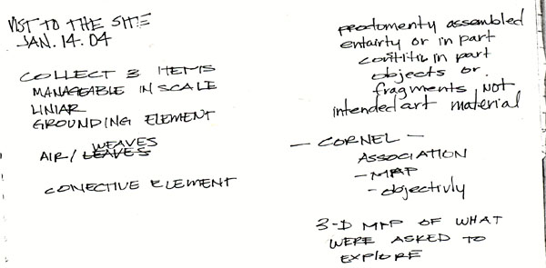
building.recycled.building
The urban and architectural
Spaces of the contemporary
metropolis is subject to
Conditions of simultaneous
inhabitation in which both
official and clandestine uses,
distinct and contradictory
programs, occupy the same
space at different times of the
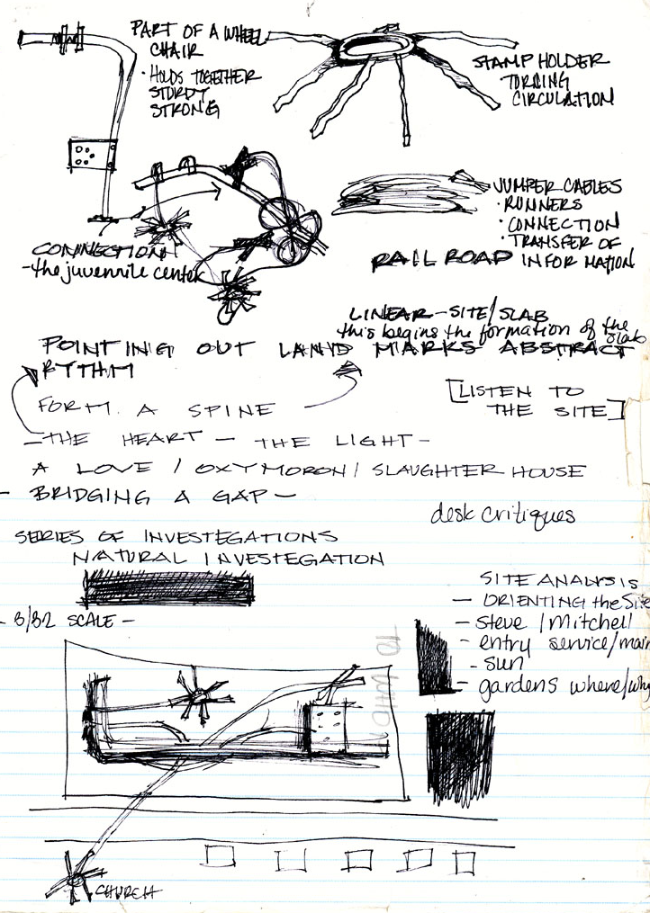
day. The common sense view
which architects hold
concerning the designation of
program or instrumental use
to a geometrical delimitation
of the urban mass –
as rooms or as city districts-
acknowledges only a single
official designation, a single
naming of the use of space.

concept
Focusing on the community
and the surrounding elements,
I plan on bringing back the
vibrant sprit of the community.
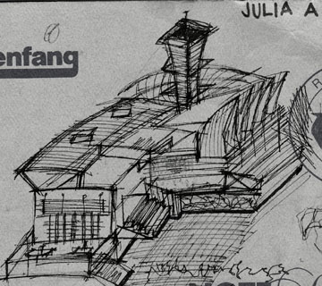
Focusing on what would
be beneficial to the community
which would be a farmers market,
which would be provided by out
side venders. The center would also
provide classes in art and writing,
etc, This allows neighbors to be better
acquainted with one another
and form a bond where neighbors could
watch out for each other. This would bring
life back to 323 E. Mitchell instead of
demolishing the existing warehouse and
establishing a parking lot.

