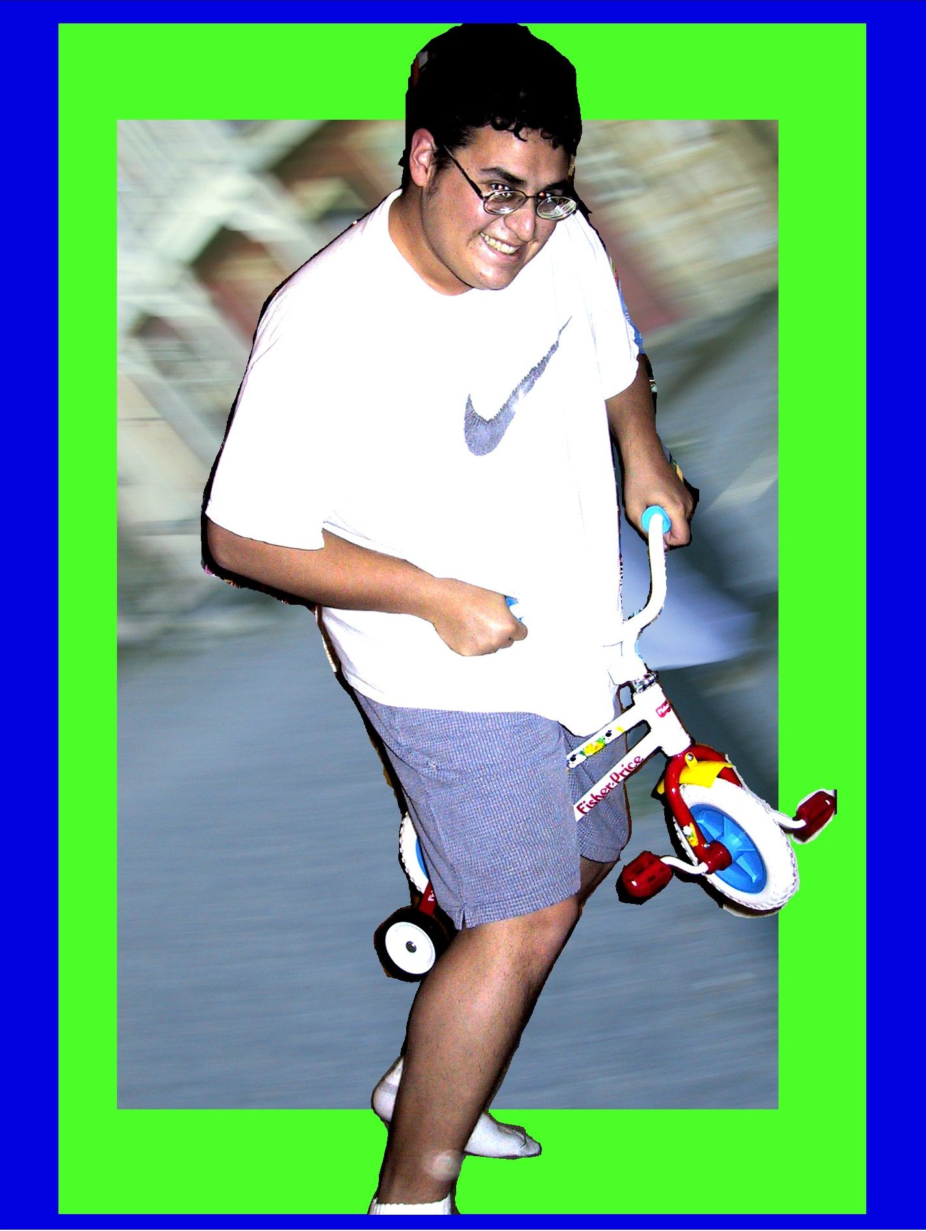
Joseph Todd Lopez
3500 Greystone Dr. apt. 225
Austin, Tx 78731
512-413-7832

Objective: To become a proficient professional Audio/Video Engineer/ Producer through education and experience in the high technology sector.

Education: Multi Media Course In High School

College Level Computer Programming (C++)

Modern Recording Techniques - Levels I and II

Experience: Have attended and engineered various recording sessions. Edited various video projects for other third parties. Filmed, edited and produced various personal/school videos ranging from music videos to documentaries. Have given A/V presentations. Have organized teams to develop and perform multi media presentations. Have interned at Digital Edge, a multi media company in San Antonio. Am currently working for the Instructional Design Group, which does multimedia/video production for the University of Texas school of Communication. Also work for Concert Sound in San Antonio, where I assist in sales and R&D. Have done extensive studies on the Digital Divide.

Audio/Video Hardware and Mediums Used:

Video:
Video cameras (VHS, 8mm, Hi8, D8, MiniDV)
Digital Video Editing on PC based computers, DV decks
Analogue Editing on VCR, VHS, S-VHS, 8mm, Hi8
Digital Capture Devices formats MPGEG (VCD, MPEG1, MPEG2)
AVI (multiple code's), RAM, MOV)

Sound:
Microphones, Microphone preamps, Analogue to Digital Converters, Digital to Analogue Converters, Digital Multitrack recorders, Hard disk recorders, sequencers, MIDI, phono and line-level preamps (surround: mono, stereo, Dolby Pro-Logic, Dolby Digital, DTS, THX EX), Amplifiers (tube and solid state), Loudspeakers (dynamic, horn, ribbon, and electrostatic), line-level cables (balanced and unbalanced), speaker cables, video cables and line conditioners. Cassette Tape, MiniDisc, CD-R/ RW, DAT, ADAT, Hard disk Recording (WAV, MP3, RAM), MIDI, LP (records)

Computer Knowledge and Background:

Programming Languages, Operating Systems and Software:

C++, HTML, Visual Basic, DOS, Window 3x, 9x, NT and 2000, MAC O/S 9 and 10, Adobe Premiere 4.2, 5.1 and 6.0, Adobe Photoshop, Cakewalk, Paint Shop Pro, MGI VideoWave, Macromedia Director, Macromedia Authorware, Macromedia Fireworks, Inspire3D (reduced version of Lightwave), Microsoft Office 95, 97, 2000, Microsoft Frontpage, Vidcap, Multiple Mpeg encoding and decoding software, Cool Edit Pro, Sound Forge, Final Cut Pro, Studio Central, Quicktime 5 Pro

Hardware:

Intimate knowledge in PC based hardware. Able to design/build equipment required for A/V productions on PC/Apple based systems including processors, storage devices, read/write devices, networking, telecommunications, displays, and printing. Built and maintains personal PC based A/V systems. Also have knowledge in Apple based editing A/V editing machines, both software and hardware.

