objects of power k. vajda

Venus Figurines: They are, in essence, small Paleolithic figurines of women, and sometimes (but a limited few) of men. The age of the Venus figurines covers a time span from 27,000 years ago, to 20,000 years ago and they have been found carved in stone, ivory and wood, and also crafted of clay. The sizes and proportions of the Venus figurines vary—the Willendorf figurine, and several others of it's type are endowed with large breasts, a large stomach, and swollen thighs, and is obviously pregnant. Analysis of the Venus figures has yielded many theories concerning their purpose within the lives of Paleolithic people. The statues themselves were crafted during the Aurignacian period, characterized by the use of new tool types with a strong dependence on blades, and the use of finer tools and points than were found in the prior period of the Peragordian. In addition, the Aurignacian also represents a hunter-gather culture which moved throughout Europe, and hunted many of the big game animals, such as cave bears, mammoths etc. With their differing physiques, and the symbolism attached to them, the Venus figurines are thought by the majority of scholars to be fertility objects.

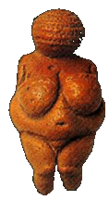

2. Kalabari Masks/Masquerade: According to Kalabari legend, a beautiful woman named Ekineba was abducted by the water spirits. When she returned to the human world, she taught people how to perform the masquerades, called "plays" in Nigerian English, which she learned from the spirits. Today Ekineba is the patroness of the masquerade society named for her, but only men can belong to the Ekine society, wear masks or perform in masquerades. African masquerade outfits frequently conceal identity by covering the face, sometimes providing a new carved face and sometimes omitting a face entirely. When present, masks are but one part of a performance that stresses music, dance and disposable ornamentation. What is principally displayed at Kalabari masquerades is special knowledge as the masquerader obeys instructions from the drums. As he makes his way through the town, the drums tell him to point to 33 shrines of state heroes and royal ancestors. Should he fail to understand the instructions or falter in the performance, the masquerader may be disgraced by the crowd—his costume may be removed and his human face revealed.

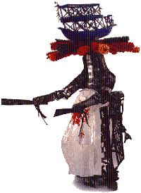

3. Chamsa: The chamsa, a hand with an eye in its center, is a Jewish good luck symbol designed to ward off the evil eye and is often seen in Eastern Europe and the Middle East.
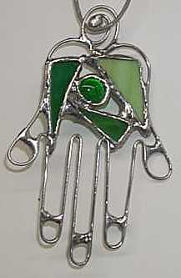

4. Eucharist/Transubstantiation: "Transubstantiation" is a term coined by the scholastic theological tradition of the Roman Catholic Church. The Holy Eucharist is a sacrament and a sacrifice. Under the appearances of bread and wine, Jesus Christ is contained, offered, and received. According to Catholic doctrine, the whole Christ is really, truly, and substantially present in the Holy Eucharist. Catechism teaches that Christ instituted the sacrament of Holy Eucharist at the Last Supper. "When Our Lord said, 'This is My body,' the entire substance of the bread was changed into His body; and when He said, 'This is My blood,' the entire substance of the wine was changed into his blood.
Christ could not have used clearer, more explicit words than 'This is My body.' He did not say, 'This is a sign of My body,' or 'This represents My body,' but 'This is My body.' Catholics take Christ at His word because He is the omnipotent God. On His word they know that the Holy Eucharist is the body and blood of Christ." (http://www.public.usit.net/driggs/transub2.htm)
Jn 6:51
I am the living bread that came down from heaven; whoever eats this bread will live forever; and the bread that I will give is my flesh for the life of the world.
Jn 6:53
Amen, amen, I say to you, unless you eat the flesh of the Son of Man and drink his blood, you do not have life within you.
Jn 6:54
Whoever eats my flesh and drinks my blood has eternal life.
Jn 6:55
For my flesh is true food, and my blood is true drink.
Jn 6:56
Whoever eats my flesh and drinks my blood remains in me and I in him.

5. Shiva Linga: Shiva Linga is a widespread Indian Phallic figure. It consists of a feminine base, Yoni, and a rising masculine portion, the Linga. The Linga artifacts, dating from the first century BC to the third century AD, are shaped like realistic phalli. Thereafter the shape becomes progressively more abstract and by medieval times, its observable portion, rising from the Yoni, forms a round block with domed apex. Shiva mythology, in fact, is a rich source of Indian thinking about sexuality, social relations, ritual, cosmic process, and metaphysics. The Male-Female union in the form of “Phallus or Shiva Linga or Yoni-Linga” or “the Ardhanarishwara,” metaphysically, is also the scientific philosophy that explains fundamentals of existence through ‘positive and negative’ or ‘male and female’ aspects of matter and life.
From the Bhavisya Purana -- In this version, Shiva (and the other two deities of the Trimurti) rape the sage Atri's wife and are punished:
"One day when the sage Atri was performing asceticism with his wife Anasuya, Brahma, Visnu and Siva came to him and offered him a boon. When Atri continued to meditate, the three gods went to Anasuya; Siva had his linga in his hand, Visnu was full of erotic feeling, and Brahma, beside himself with desire, said, 'Make love to me or I will die.' When she heard this coarse speech, Anasuya made no reply, for, although she feared the anger of the gods, she was true to her husband. But the three gods were overcome by delusion, and they raped her by force. Then she became angry, and she cursed Siva to be worshipped as a linga, Brahma to be worshipped as a head, and Visnu to be worshipped as feet, in order to ridicule them all, and she cursed them all to be reborn as her sons. Because of this, Siva was born as Durvasas." -- Bhavisya Purana 3:4:17:67-78. [O'Flaherty, Wendy D. The Origins of Evil in Hindu Mythology. University of California Press. ISBN 0-520-04098-8. p.302-303].
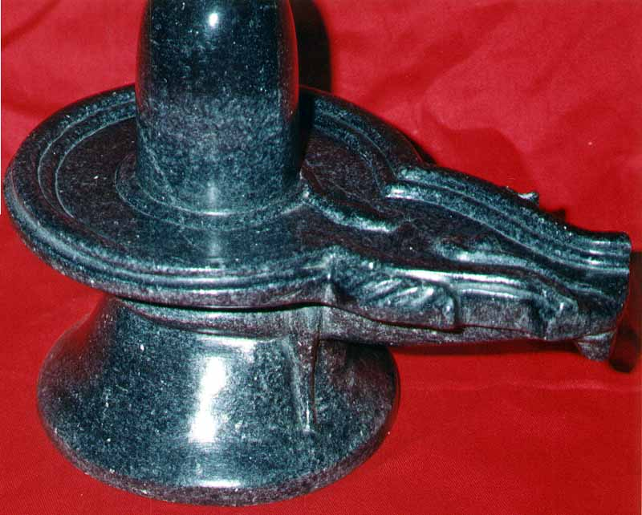
6. Runes (Norse): The runes were never the basis of a spoken language, but in addition to their written use they were believed to be sacred and very powerful magical symbols, each linked to a god and a specific meaning. They were a means of divination. Rune casters, whom were often women, used runes to cast lots and tell fortunes. Modern versions include a blank rune, which symbolizes the Unknowable.

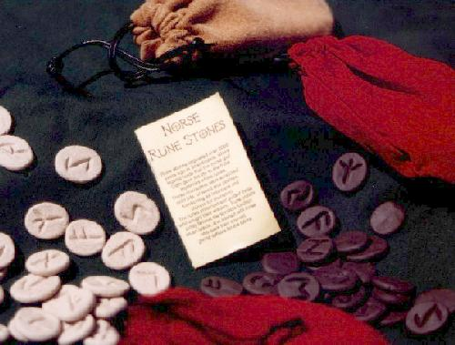

7. Kali: Kali ("the black one") is the Hindu mother goddess, symbol of dissolution and destruction. She destroys ignorance, maintains the world order, and blesses and frees those who strive for the knowledge of God. In the Vedas the name is associated with Agni, the god of fire, who had seven flickering tongues of flame, of which Kali was the black, horrible tongue. This meaning of the word has meanwhile been replaced by the goddess Kali, the grim consort of Shiva. Her appearance is fearsome: baleful eyes, a protruding tongue, and four arms. In her upper left hand she wields a bloody sword and in her lower left hand she holds the severed head of a demon. With her upper right hand she makes the gesture of fearlessness, while the lower right hand confers benefits. Draped around her is a chain of severed human heads and she wears a belt made of dismembered arms. As the Divine Mother she is often represented dancing or in sexual union with Shiva. As Bhavatarini, the redeemer of the universe, she stands upon the supine form of her spouse.
The Hindu distinguishes a benign Kali (dakshina) from a fearful Kali (smashan) by the position of her feet. If Kali steps out with her right foot and holds the sword in her left hand, she is a Dakshina Kali. If she steps out with her left foot and holds the sword in her right hand, she is the terrible of the Mother, the Smashan Kali of the cremation ground. According to Tantrics, one's spiritual disciplines practiced in a cremation ground bring success quickly. Sitting next to corpses and other images of death, one is able to transcend the "pair of opposites" (good-bad, love-hate, etc) much faster than another person who blocks out the unpleasant aspects of life. The cremation ground's images arouse instant renunciation in the mind and help the Tantric to get rid of the attachment for the body.
Kali is the color of the darkest night-a deep bluish black. As the limitless Void, Kali has swallowed up everything without a trace, and therefore she is black. Kali's hair is disheveled and, thereby, symbolizes hers boundless freedom. Another interpretation says that each hair is a jiva (individual soul), and that all souls have their roots in Kali. She has three eyes, the third one stands for wisdom and a protruding tongue. Kali has four arms. The posture of her right arms promises fearlessness and boons while her left arms hold a bloody sword and a freshly severed human head. Looking at Kali's right, we see good, and looking at her left, we see bad. Kali is portrayed as naked (clad in space) except for a girdle of human arms cut off at the elbow and a garland of fifty skulls. The arms represent the capacity for work, and Kali wears all work (action), potential work, and the results thereof around her waist. The fifty skulls represent the fifty letters of the alphabet, the manifest state of sound from which all creation evolved.
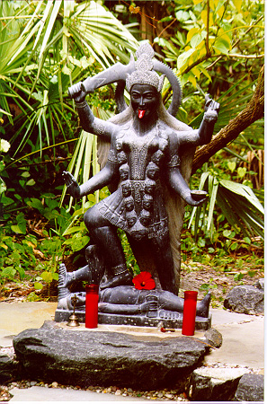
8. Haitian Vodou (Objects used in service to the lwa): The drum is the most sacred of these objects, for it speaks with a divine voice. Without it there would be no Vodou. Certain objects are present in nearly every temple or home altar. Others reflect the personal history or tastes of the servitor and his or her spirits. Almost anything can be dedicated to a lwa and then set upon an altar or incorporated into some larger religious work. All these objects can possess magical powers, for they are all capable of transforming the natural into the supernatural. To open the channel for divine energy, the senses must be quickened. Sound is a fundamental pathway for the divine. Senses of sight, smell, taste and touch are also stimulated in Vodou.
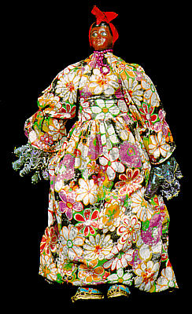
9. Bedu: Bedu is a plank mask that is used throughout the Bondoukou region of Côte d'Ivoire, West Africa. Generally speaking, Bedu appears once a year, for between a week and a month, at the New Year festivities. These celebrate the renewal of the natural and the social order. Bedu embodies this transition, because it is itself seen as the product of a transfer. The mask is conceived as the reproduction (domestication) of the Bedu wild animal that lives in the bush. Sculpting transforms Bedu into a domesticated animal while painting invests it with authority.
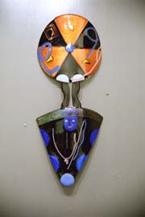
10. Swastika: The swastika came from the Sanskrit word Swasticka which means, "conducive to well- being"; "su" meaning "good" and "asti" meaning "to be." The swastika is an equilateral cross with arms bent at right angles, all in the same direction, usually the right, or clockwise. The swastika is a symbol of prosperity and good fortune and is widely dispersed in both the ancient and modern world. It originally represented the revolving sun, fire, or life. The swastika was widely utilized in ancient Mesopotamian coinage as well as appearing in early Christian and Byzantium art, where it was known as the gammadion cross. The swastika also appeared in South and Central America, widely used in Mayan art during that time period. A variant with only three arms is used on the Isle of Man, and is known as a "triskeleon." It is usually represented as three legs and suggests the act of running. This may be a holdover from its associations with the goddess Bridget (Bride). Depicted within a triangle symbolizing the goddess Astarte in some parts of the Ancient Middle East. In North America, the meaning has been a "Wheel of Life," a "Sun-Wheel," the four points of the compass, the four winds, Man himself, a symbol of the Hopi emergence into the current world (showing the directions taken by the various tribes in their wanderings). The swastika still continues today to be an extensively used sign in Buddhism, Jainism, and Hinduism. In Buddhism, a swastika represents resignation. In Jainism, it delineates their seventh saint, and the four arms are also used to remind the worshiper of the four possible places of rebirth; the animal or plant world, in Hell, on Earth, or in the spirit world. To Hindus, the swastika with the arms bent to the left is called the sathio or sauvastika, which symbolizes night, magic, purity, and the destructive goddess Kali. In both Hinduism and Jainism, the swastika or sathio is used to mark the opening pages or their account books, thresholds, doors, and offerings. In Nazi Germany, the swastika with its arms turned clockwise became the national symbol. In 1910, a poet and nationalist Guido von List suggested that the swastika as a symbol for all anti-Semitic organizations. When the National Socialist Party was formed in 1919, it adopted the ancient symbol of the swastika. In 1935, the black swastika on a white circle with a crimson background became the national symbol of Germany. The major difference between the Nazi swastika and the ancient symbol of many different cultures is that the Nazi swastika is at a slant, while the ancient swastika is rested flat.
11. Herm (Ancient Greek): Herms are statues consisting of a plain shaft surmounted by a head, shoulder bust or sometimes a head and torso. It originated in ancient Greece and has been used since in a variety of settings, often architectural or open-air. Ancient Greek herms usually featured a head of the god Hermes, from which the type derives its name, and the front of the shaft was carved with male genitals. Herms were characteristically located out of doors, often in streets and highways, borders and open countryside, as well as in sporting complexes such as gymnasia and palaestras. Herms in ancient Athens served as wayside shrines, marked sacred places or were set up as memorials. The range of locations variously reflects Hermes’ nature as a phallic fertility deity, as a mediator (the Homeric messenger of the gods) and bringer of good luck; he was later adopted as the tutelary deity of the arts and sciences, of heralds, markets and roads.
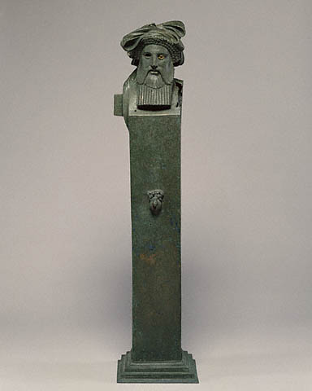
20 things that may have substantial power and meaning for my life at this time:
- car
- airplanes
- hanes white v-neck t-shirts
- federal student loan program
- prescription medications
- phone
- dirt
- old Hi8 video camera
- all old family pictures
- smell of bleach
- boxe of old letters
- my father’s old Super8 camera
- stuffed pink poodle
- lemon tree
- 90 min. Maxell cassette tape received in 5/97
- monkey apron from Ghana
- the $5 park slope flea market painting
- holga
- mona hatoum
- mikvah

20 things that people empower themselves with in the 21st century:
- radical politics
- music
- vibrators
- new haircuts
- children
- academic degrees
- food
- prescription medications
- anti-aging skin treatments (botox, dermabrasion, etc.)
- jobs
- religion
- titles
- bigger cars
- cell phones
- “connectivity”
- illusions of grandeur
- guns
- cash
- the misery and subordination of others (the death penalty, etc.)
- men

