Name: Randy Kelley
UTEID: kelleyrw
Permanent Address: 9902 Sagecourt Dr.
Houston, TX 77089
Email Address: randaddy444@yahoo.com
Daytime Phone Number: (512) 507-7479
Ticket number(s): 061900438
062200112
Vehicle Plate Number (including state): TEXAS – D97GXY
University Status: Student
Reason(s) for Appeal:

TICKET #1 (061900438):
I was parked at a university meter on Whitis Ave. on November 16, 2005 at approximately 3:30pm. When I came back out to put more change in the meter at approximately 4:30pm, I found that the space in front of me had been vacated while there was still time left on the meter. I pulled forward and reminded myself that since there were 30 minutes left on the meter, I would have to return by 5 to deposit more change, or move to another spot. I returned to find that I had received a parking ticket. According to the ticket, it was issued 12 minutes after I left, and 18 minutes before I had gotten there. Because I know my meter read 30 minutes left, I was confused. I considered the face that the meter-person may have seen me parked at an expired meter, had intended to give me a ticket (on their way back?), and didn’t notice I had switched to a meter with time on it. Either way, because I was parked legally at a University meter, on which I still had parking time (regardless of whose change was actually deposited), I feel as though I should not be responsible for the payment of this ticket.

TICKET #2 (062200112):
This day was very confusing for me. Once I saw the previous ticket on my car, knowing I still had to stay on campus for a few more hours, I got a bit upset. I knew the first ticket was incorrect, seeing as how there were still minutes on my meter. So I figured it wouldn’t matter whether I put more change in my meter or not. Besides, there was already a ticket on my windshield, which I assumed meant my car was already “marked” for the day. I was incorrect. I received another ticket three hours later, at 7:57pm. My assumptions, of course, were wrong. These are therefore not my reasons for appealing the parking ticket. My appeal regards what actually appears on the ticket, which confuses me even more. Apparently a different officer got me this time (G188, rather than A006). What first caught my attention was that under comments, the officer wrote “DROVE OFF – NO CITE LE.” I’m not too clear on what “no cite le” means, but I think I understand what he/she was trying to convey with “drove off,” though it still makes no sense to me. I had not moved. My car was still at the same meter. And had I driven off, how was he/she able to give me a ticket? I assure you, no officer chased me and slid a ticket under my left windshield-wiper as I was driving off. The ticket was there when I came back to the car at approximately 9:30pm. Another thing that caught my attention was the recorded address. Again, I had not moved. My car sat in the same spot since before the last ticket I received. Conversely, the address that appeared on the ticket was different. On the first ticket (061900438), the recorded address was 2500 Whitis. On this ticket, it had changed to 2400 Whitis. The new address is an entire city (or campus?) block away. The story told by this second ticket (as best constructed by me) is that the officer saw me parked at an expired meter. Then, as he/she was coming to give me a ticket, I sped off to another spot down on the next block. The officer chased after me and was able to give me a ticket anyway. Though more exciting, this story is wholly untrue. My car sat in the same spot. Furthermore, I went and checked out 2400 Whitis, only to find that there are no University parking meters there. Therefore, the officer’s claim that I was “parking overtime at a meter” (listed under “Violation”) at 2400 Whitis is completely false. For all of these reasons, I feel the citation is utterly bogus and should be dismissed.

**I have taken the liberty to enclose two pictures which I snapped from my camera phone. I feel they serve as compliments to my appeal in that they show exactly where everything allegedly took place. I have drawn two circles (with a short explanation) on the first picture to help in identifying what I detail in the above appeals.

Thank you for reviewing my appeal. Best on your decision and on this holiday break.

Sincerely,
Randy Kelley

enc: A page containing two pictures of locations listed on citations.
PICTURE #1: 2500 Whitis
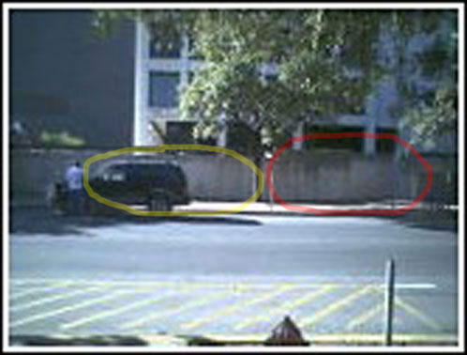
Explanation: As detailed in my appeal for Ticket #1 (061900438), the spot which I have circled red is the first University metered spot in which I parked. At approximately 4:30pm, I moved forward into the spot which I have circled yellow (which already had time on it), where I remained for the rest of the day.

PICTURE #2: 2400 Whitis
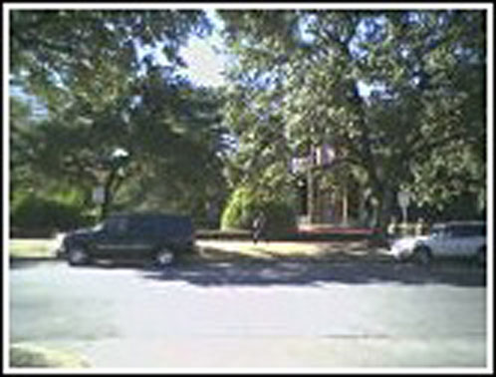
Explanation: As detailed in my appeal for Ticket #2 (062200112), 2400 Whitis is a completely different location than 2500 Whitis. Although those black SUV’s look similar, they are in fact two different vehicles parked at two different campus blocks.

