# Introduction

You know that swell moment at 2:10 in Arcade Fire’s song “My Body is a Cage” when the organ really kicks in and you get that *whoosh* feeling?[1] Somehow, at that moment, sound for me becomes a feeling. It has the same affect at the same spot for some friends of mine, too. We’ve commented to one another on this phenomenon.

My sort of vague colloquial explanation is that it is about expectations. The song is structured in such a way that it sets the audience’s expectations at a certain point, then exceeds them in successive intervals, creating a sort of emotional payoff. While I started thinking of this issue in terms of audience emotions and expectations, I gradually became more interested in structural, technical, neurological and experimental explorations of the issue that for me was encapsulated in a swell two minutes into a pop song. This exploration led to the creation of an instrument, a pleasant loop, and a sound experiment.

# Structural Analysis of Swell in Arcade Fire’s “My Body is a Cage”

If you look at the structure of the song, there are little swells at, more or less, even intervals leading up to the big pay off. Two of them can be seen in figures 1 and 2, and the big payoff can be seen in figure 3.

Small Swell

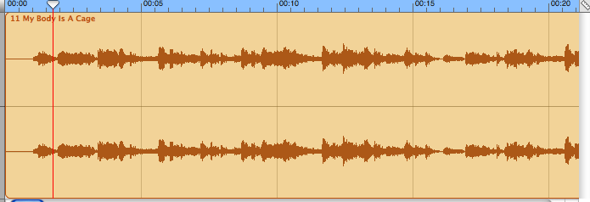

Figure 1. A small swell in “My Body is a Cage” roughly at 00:05.

The song begins *a capella* and then gradually adds parts, each time creating a little swell.[2] After just over a minute, we have our first orchestrated swell, which I call a Medium Swell.[3] But we might also refer to this as a sort of our first dose of what is to come. This is the hook, not in the traditional sense of a repeated pop chorus, but rather in the sense that it sets our expectations so that we expect at least this size of swell next time.

Medium Swell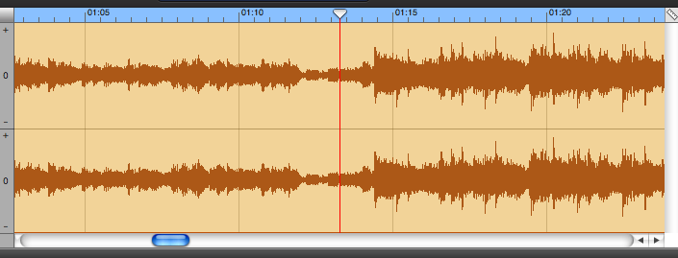

Figure 2. A medium swell in “My Body is a Cage” roughly at 01:15.

What we get next time is a big, wall-of-sound-style swell. This coincides with the big emotional rush. So by looking at Figures 1, 2 ,and 3, we can visualize how an increase in _____ corresponds to an increased emotional response.

The Big Swell

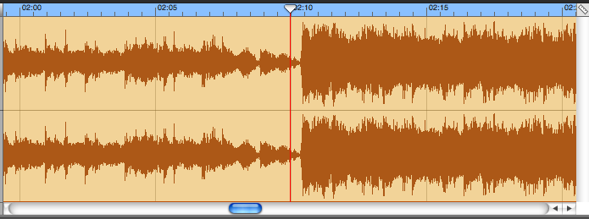

Figure 3. The big swell in “My Body is a Cage” roughly at 02:10.

But although this structural analysis might say something about the structuring of audience expectations, it doesn’t really explain how music gets translated into a feeling. That must be explained in terms of neurotransmitters.

# This is Your Brain On Music

As I began thinking about how music gets translated into a feeling, I started thinking about neurology. Neuroscience doesn’t provide the only vocabulary we could use to talk about this phenomenon, but because of the various new ingenious ways we’re learning to study the brain, the language of neuroscience is particularly useful right now.

Not being a neuroscientist myself, I must rely on translators. The popularity of neuroscience (and the influence of my friend Chris) led me to a Radio Lab segment about Igor Stravinsky’s “The Rite of Spring.” In brainy vocabulary, the folks at Radio Lab explain how, in the span of a year, “The Rite of Spring” first caused riots and then was lauded by critics as a hugely important work of art. Still later, it became the stuff of Disney movies.[4]

This is what led me to explore the plasticity of our brain and how it adapts to dissonance. It was a lucky coincidence that my gaze happened to fix upon a pump for a long-since-permanently-deflated air mattress, a melodica, and a backback all in matter of seconds. A length of tube and some duct-tape later (both of which were lying around not far away) and I had the perfect machine for creating dissonance. (See Figure 4.)

The Automelodica

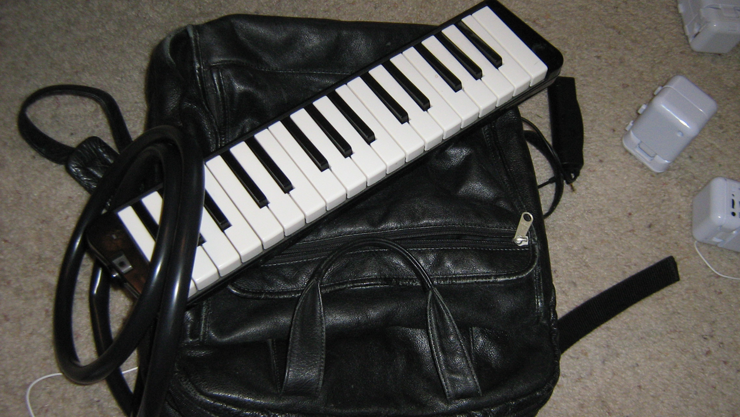

Figure 4. The Automelodica with the pump hidden in the backpack.

# Materials

The Automelodica consists of:

* a Colman air mattress pump (takes 4 D batteries)[5]
* a Honer melodica[6]
* a backpack[7]
* a length of tube from Lowes.
* duct tape

In addition to the Automelodica, for the presentation I used:

* 3 sets of cheap speakers from Office Max.[8]
* a 3-jack headphone booster[9] (takes 2 AA batteries)

Presentation Materials

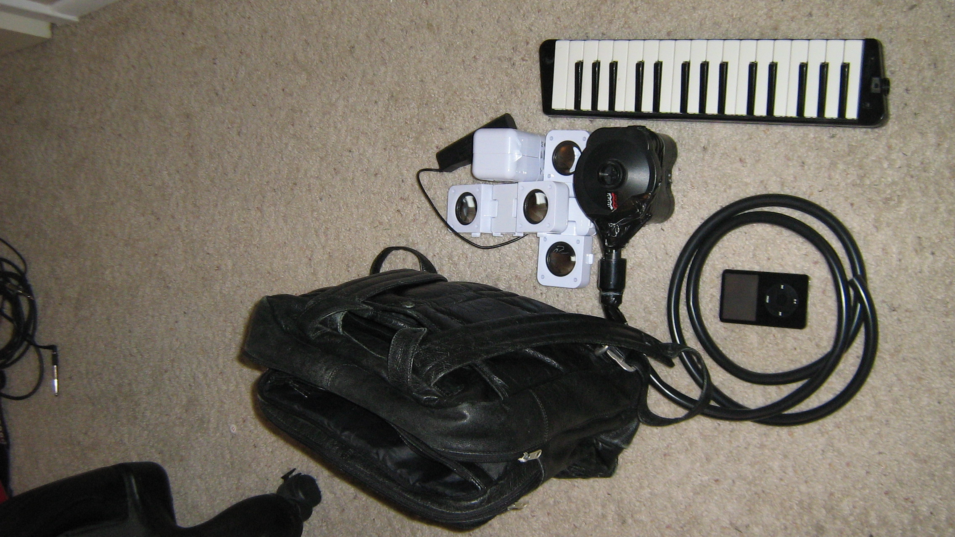

Figure 5. The materials used in the presentation: an iPod, an air mattress pump, 3 iPod speakers, a 3-jack speaker amp, a backpack, and a melodica.

# Fabricating an Instrument, Fabricating a Narrative

Now, I’m somewhat refiguring this story to fit a narrative arc. In actuality, what happened was much more recursive. I think I listened to the show first months before I ever put together the melodica or started thinking about consonance and dissonance. Then I created the automelodica on a random whim just after the second week of soundscapes. Then I wrote a decidedly consonant song for the presentation of the new intstrument.[10] Then I decided I hated the song. Then I started thinking about why I hated it. I hated it because I was too focused on learning to play this new instrument and making tweaks (dampen in air-intake valve with my foot and a pillow or my arms in a backpack?) to focus on making an interesting composition or thinking about what this new instrument could do that a regular melodica could not.

When I started thinking about what this instrument could do, I knew the answer was merely indefinite mechanical sustain. I figured I could sustain a really nice chord for a long time. But I had noticed before I hooked it up to the super-lungs that one of the most interesting things about the melodica’s sound was it’s sort of reedy dissonance. I thought of it as one of the most pleasant kinds of dissonance I’ve heard before. So I thought about sustaining a really dissonant chord for a while. Then I remembered Stravinsky and the Radio Lab show and I thought I’d listen to it again until I understood and could explain in my presentation what the dissonance was doing on a neurological level. But there was so much good stuff I thought, I should just play this for the class. But then I thought I wouldn’t have time to both play a dissonant note long enough to make the point and play the audio clip that explained what was going on. So I just cut up the show and pieced together as much of it as I could fit into five minutes.[11] And then I decided just to play over top of it as a performance of what the show itself was explaining.[12]

1. A sample can be found at: [http://www.actlab.utexas.edu/~wburdette/sounds/body_is_a_cage_swell.mp3](http://www.actlab.utexas.edu/~wburdette/body_is_a_cage_swell.mp3).
2. A sample can be found at:

   [http://www.actlab.utexas.edu/~wburdette/sounds/body_is_a_cage_intro.mp3](http://www.actlab.utexas.edu/~wburdette/body_is_a_cage_swell.mp3)
3. [http://www.actlab.utexas.edu/~wburdette/sounds/body_is_a_cage_med_swell.mp3](http://www.actlab.utexas.edu/~wburdette/body_is_a_cage_med_swell.mp3)
4. The entirety of the show is located on the show’s Web page at <http://www.wnyc.org/shows/radiolab/episodes/2006/04/21>
5. The pump is available online for $16 at: <http://www.coleman.com/coleman/colemancom/detail.asp?product_id=5999E300&categoryid=10063>
6. The melodica can be obtained online from Guitar Center for $99 at: <http://www.guitarcenter.com/Hohner-HM-32-32-Key-Melodica-420609-i1133687.gc>
7. I used a leather one, but consider the material your backpack is made of. I noticed that if I put the intake valve of the pump against the satin part, it choked. Putting it against the leather allowed from more subtle control of the dampening of the intake valve.
8. They list online at $14.99, but I got them for $4.99 at the Office Max at 5th and Congress. <http://www.officemax.com/omax/catalog/sku.jsp?skuId=21241853&searchString=speaker>
9. Available online at RadioShack.com for $29.99

   <http://www.radioshack.com/product/index.jsp?productId=2732095&cp=&sr=1&origkw=headphone+amplifier&kw=headphone+amplifier&parentPage=search>
10. The “song” (it’s more of a loop) is available here:
11. My edited version of the show is at: <http://www.actlab.utexas.edu/~wburdette/sounds/soundscapes_presentation_no_melodica.mp3>
12. A version of that (not the one performed live in class) is available here: <http://www.actlab.utexas.edu/~wburdette/sounds/soundscapes_presentation.mp3>